European Care Certificate
Training Pack

Handouts

Handout 1
The Basic European Social Care learning Outcomes (BESCLO) cover the following:
- The values of social care
- Understand the need to promote the following values at all times: individuality, rights, choice, privacy, independence, dignity, respect and partnership.
- Understand the need to promote equal opportunities for the individual(s) you are supporting.
- Understand the need to support and respect diversity and different cultures and values.
- Understand the importance of confidentiality.
- Understand the limits of confidentiality.
- Promote life quality for the individuals you support
- Understand the importance of finding out the history, preferences, wishes, needs and abilities of the individual(s) you are supporting.
- Understand the need to make sure that everything you do is based around the individual(s) you are supporting.
- Understand the need to enable the individual(s) you support to control their own lives and make informed choices about the services they receive Be aware of the impact of assistive devices on the quality of life and participation of the individuals you support
- Working with risk
- Recognise that the individual(s) you support have the right to take risks.
- Identify the main principles involved in risk assessment.
- Be aware of the dilemma between enabling service users to take risks and ‘duty of care’.
- Understand own responsibilities in relation to managing risk.
- Know how to inform the relevant people of identified risks.
- Understand your role as a support worker
- Understand the value and importance of working in partnership with unpaid carers / advocates / significant others.
- Understand the importance of good teamwork.
- Understand why it is important to follow policies and procedures, legal frameworks and the aims and objectives of the organisation you work for.
- Understand the responsibilities and limits of your relationship with the individual(s) you support.
- Understand the need to be reliable and dependable.
- Safety at work
- Know how to safely store and dispose of substances and articles that are harmful to health.
- Know how to assess risks in relation to moving and positioning people and/or objects.
- Know safe moving and positioning techniques in relation to people and/or objects.
- Know how and what you are not allowed to do in relation to moving and handling at this stage of your training. Guidance example: You must not use moving and handling equipment until you have been trained to do so.
- Understand how to promote fire safety in your work.
- Know what to do in response to illness or accident.
- Understand basic emergency first aid techniques.
- Understand what you are not allowed to do in relation to emergency first aid at this stage of your training. Guidance example: You must not attempt to undertake any emergency first aid that you have not been trained to offer.
- Understand the main routes of infection.
- Know how to prevent the spread of infection.
- Know how to wash hands properly.
- Understand how to keep workplaces secure.
- Recognise possible risks to your personal safety and well being in your work, and the safeguards required to minimize these
- Communicating positively
- Know what motivates people to communicate.
- Recognise the main barriers to communication.
- Understand how behaviour is a form of communication.
- Understand the basic forms of verbal/non-verbal communication and how to use these in your work.
- Understand how to use touch to promote communication.
- Understand when touch is not appropriate.
- Know how to record information that is: understandable, relevant to purpose, clear and concise, factual and checkable. Guidance: Where information is written, it must be legible. Where information is recorded on tape, it must be audible.
- Understand the importance of, and your role in, record keeping.
- Recognise and respond to abuse and neglect
- Know what the following terms mean: Physical abuse, Sexual abuse, Emotional abuse, Financial abuse, Institutional abuse, Self-neglect, Neglect by others.
- Recognise the signs and symptoms associated with the following: Physical abuse, Sexual abuse, Emotional abuse, Financial abuse, Institutional abuse, Self-neglect, Neglect by others.
- Understand the need to report any suspicions about the abuse or neglect of the individual(s) you support.
- Know when and to whom suspected abuse/neglect should be reported.
- Understand how to respond to a disclosure of abuse from an individual you are supporting.
- Understand your first responsibility is to the safety and wellbeing of the individual/s you support.
- Know how and when to report any resource or operational difficulties that might affect the delivery of safe care. Guidance example: inadequate staff cover.
- Know how and when and your duty to report the practice of colleagues which may be unsafe. Guidance example: not following agreed procedures or a care plan.
- Know what to do if you have followed your organisation’s policies and procedures to report suspected abuse, neglect, operational difficulties or unsafe practices, and no action has been taken.
- Develop as a worker
- Understand the need to gain skills and knowledge to support and develop your work.
- Know how to use internal and/or external supervision effectively.
- Know the symptoms of stress.
- Understand ways to avoid or deal with negative stress at work.

BESCLO 1. The values of social care.

Handout 2

Values of care
The main values that support working in social care are:
- Rights
This is ensuring an individual’s rights are upheld at all times, especially when an individual may not be in a position to ensure themselves that their rights are being upheld. This includes the rights of people to be treated equally and to be valued as individuals.
- Individuality
This is about ensuring you treat each person as an individual and not as if they are the same as everyone in a group. Encourage an individual to be himself or herself, to develop a sense of identity which is special and unique.
- Choice
This is about choice in basic things such as what we wear and what we eat for breakfast, along with larger issues such as where we live and how we choose to live our lives. You need to ensure that the individuals who you work with also understand the consequences of the choices they make. This means they are making ‘informed’ choices.
- Privacy
This is linked closely to respect and dignity. It is about having time and space on your own, if you want it. You should ensure privacy is maintained when you are working with an individual on such things as their personal care or finances.
- Independence
When you are working in the care sector the temptation is to want to ‘look after’ an individual, which may result in stifling his or her independence. Your role is to empower the individual to develop and maintain their independence as much as possible.
- Dignity
This is related to an individual’s self esteem, giving them a degree of worth or honour. This is achieved through personal development and personal expression. Dignity is promoted in how we speak to people and the way we do things with others.
- Respect
This is linked to dignity and is about showing regard and courtesy for others. Ensuring that what an individual says and does is important and matters.
- Partnership
This is about working together to achieve aims and goals. Working together with the individuals you support, their family, friends and carers, colleagues and other professionals.
- Empowerment
This is about enabling the person to do things for themselves, giving them a sense of confidence and competence.
- Inclusion
This is about ensuring the individual you support is included in activities, making choices and making decisions in all aspects of their life
- Self determination
Self-determination means being who you want to be and making the choices that make this possible. It is important to encourage individuals to have self-determination, so that they can make choices and decisions about their life.

BESCLO 1. The values of social care.

ADD Legislation and Guidance Supporting the Principles of Care

BESCLO 1. The values of social care. Handout 4

UN Convention on the Rights of People with Disabilities
There are also the United Nations (UN) guidance and laws relating to upholding the rights of people with disabilities.
The UN convention on the rights of people with disabilities does not define new rights, this is just putting in law what exists.
It spells out clearly and unconditionally that people with disabilities have equal access and right to the full and effective enjoyment of all human rights.
The purpose of the UN Convention is:
To promote, protect and ensure the full and equal enjoyment of all human rights and fundamental freedoms by all persons with disabilities and promote respect for their inherent dignity.
Persons with disabilities include those who have long-term physical, mental and intellectual or sensory impairments, which in interaction with various barriers may hinder their full and effective participation in society on an equal basis with others.
It defines disability is terms of the social model of disability – not the medical model. It talks about impairments, which might hinder people taking their full part in society. It looks at what society needs to do to make reasonable adjustments to help overcome these impairments – these are discussed in detail – how things need to change in order to give access to buildings, transport, education, jobs, housing etc
There are eight guiding principles to the UN convention
1. Respect for inherent dignity, individual autonomy including the freedom to make one's own choices, and independence of persons
2. Non-discrimination
3. Full and effective participation and inclusion in society
4. Respect for difference and acceptance of persons with disabilities as part of human diversity and humanity
5. Equality of opportunity
6. Accessibility
7. Equality between men and women
8. Respect for the evolving capacities of children with disabilities and respect for the right of children with disabilities to preserve their identities

BESCLO 1. The values of social care. Handout 5
Medical Model of Disability
Under this model, disabled people are defined by their illness or medical condition. This often causes them to be disempowered: medical diagnoses are used to regulate and control access to social benefits, housing, education, leisure and employment. The medical model views the disabled person as dependent and needing to be cured or cared for. The disabled person is seen as problematic, they cannot look after themselves, they cannot get about, they cannot make decisions, they are sick and need help, they need to be cared for.
The disabled person is the problem, not society. Control resides firmly with professionals; choices for the individual are limited to the options provided and approved by the 'helping' expert. It is thought that it is the individual disabled person who must adapt to the way in which society is constructed and organised, the disabled person is the problem, not society.
This model is strongly rejected by most disabled people and the organisations that support them. However it still influences and impacts on many attitudes towards disabled people.
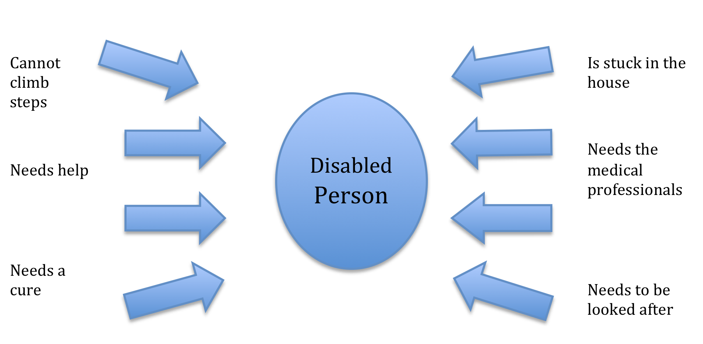

BESCLO 1. The values of social care. Handout 6
Social Model of Disability
The Social Model of disability is civil rights based approach to disability developed by disabled people in the 1970s and 1980s. It focuses on challenging and removing barriers, which prevent disabled people from living full and active lives. These barriers are many and varied and can lead to institutional discrimination, for example:
- Buildings are built that disabled people cannot get into.
- Information is produced in ways that disabled people cannot use.
- Attitudes and stereotypes about disabled people prevent them from having the same opportunities as non-disabled people.
- Special services are created that keep them segregated and cut off from everybody else.
The social model of disability can achieve equality for disabled people by:
- Creating buildings that are accessible.
- Producing information in accessible formats.
- Challenging stereotypes and assumptions.
- Ending segregated services.
- Enabling disabled people, doing things for themselves.
- Disabled people having rights under the law.
- Ensuring that disabled people’s rights are upheld
The ECC is based on the principles and values of support, the social model of disability, the UN Convention and the Laws and Guidance of each country. It applies them to the basic day-to-day tasks and decisions, which care/support staff have to make. It is about how you work and how you promote the interests of the individual against those of the organization.

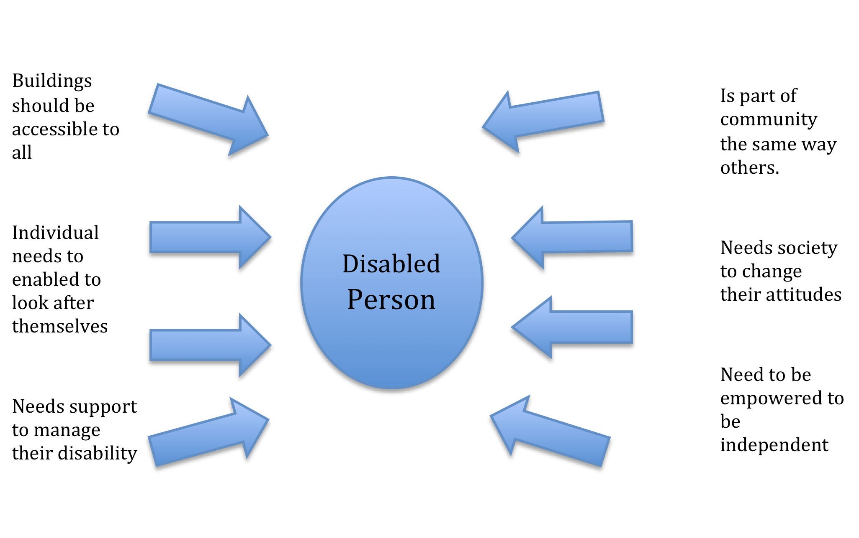

BESCLO 1. The values of social care. Handout 7
Discrimination often occurs on the grounds of:
- Age
- Mental health
- Gender
- Sexuality
- Class
- Religion
- Beliefs
- Disability
Your role is to ensure that any discrimination that is unfair is not allowed to happen.

What do we mean by prejudice, discrimination and oppression?

Prejudice
leads to

Discrimination
leads to

Oppression

BESCLO 1. The values of social care. Handout 8

Prejudice
Means ‘pre’ ‘judging’. Prejudice describes how we can think about other people. Prejudice means making assumptions about individuals or groups of people based on incomplete information. The prejudice often remains unchanged even when the proper information is provided, and is therefore illogical.
An example of this would be an employer who wishes to recruit a new staff member to his team, and has some prejudiced ideas that all people who use wheelchairs also have learning disabilities.

Discrimination

This when someone acts on prejudice.
It is the unfair and unequal treatment of an individual or a group of people.
An example of discrimination would be if the employer in the example above decided, before any interviews started, that Mr. Jones is not suitable for the post because he uses a wheelchair.

Oppression

This is prolonged harsh, cruel treatment of an individual or group by those who think this is ‘normal’ practice. Oppression is institutionalised discrimination.
When people have prejudices and discriminate against people because of them, oppression can occur. In the example, Mr. Jones and other people who use wheelchairs may find it difficult to get employment because of the prejudices and discrimination against them.

Multiple discrimination
This is when an individual has more than one part of their identity that puts them at risk of being discriminated against e.g. being disabled, black and an older woman, or being gay and working class could lead to discrimination.

Confidentiality
Maintaining confidentiality is about not sharing information with others unless this is deemed to be necessary in their best interests and with their consent. It is an important aspect of respecting a person’s basic human rights, treating them with respect, maintaining their trust and recognising their need for privacy
There are, however, occasions when you need to tell someone, for example, about suspected abuse or neglect. On these occasions you must follow your employer’s policies and procedures regarding the reporting of such incidents.
Not having clear policies and procedures can only be harmful to the individuals that you are working with either by not keeping things confidential or by not ensuring the right people are told what they need to know in order to act effectively.

BESCLO 2. Promote Life quality for the individuals you support.

Handout 9
Person Centred Support.
Person-centred support is exactly what it sounds to be – it is providing a support package for an individual where they are at the centre of all that you do. Everything that is involved in the individual’s support package has the individual involved in the decision-making of how they want that support package to be. We have now covered the importance of the values and principles that underpin working in a person-centred way, but we also need to look at how we can make sure that we implement this, i.e. that we actually do it.
A way to do this is to ensure that any planning that we do is person-centred. We have mentioned how the plan will be focused on the individual, it will take into account their hopes, aspirations, needs (including physical, health and medical care) and it also includes; relationships, education, employment, spiritual and cultural beliefs and social life.
The plan itself should be recorded in a way that the individual also understands.
If the person receiving support has difficulties with written words, for example, ways should be found to record the plan in a visual way so they can understand and participate.

You will also need to understand about the individual’s background and history, as this will also form part of their plan and help those involved to know and understand more about what the individual is all about. The plan needs to be reviewed and updated regularly. A good person centred plan will include:
- Health needs
- Educational needs
- Employment options
- Social needs
- Housing needs
- Religious needs and mattres
- Political views
- Cultural needs and matters
For a person-centred plan to work it needs to be a ‘living and breathing’ document, in other words you cannot just write it one day and think it is done.
It will be carefully planned, implemented, monitored and changed as circumstances and views alter. New health issues, new behaviours, jobs or training or housing choices may all trigger a change.

A good plan will also think about the individual not only now, but their plans, hopes, etc. for their future. It will include ways in which the individual may grow and develop along with improving their well-being. Their well-being includes their confidence, self-esteem, their wants and needs, hopes and aspirations, spiritual beliefs, their contact with others, forming relationships, showing warmth, affection and experiencing pleasure, joy and fulfillment – all the things that make any individual’s life more complete.

BESCLO 2. Promote Life quality for the individuals you support.
Handout 10
Five steps to person centred planning:
- The person is at the centre – person-centred planning is rooted in the principles of rights, independence and choice. It requires careful listening to the individual and results in informed choice about how an individual wants to live and what support/ care best suit the individual.

2. Family members and friends are full partners – person-centred planning puts the individual in the context of their family and communities. The contributions that friends and families can make are recognised and valued and gives a forum for creatively negotiating conflicts about what is safe, possible or desirable to improve a individual’s life.

3. Person-centred planning reflects an individual’s capacities – what is important to the individual (now and for the future) and specifies the support they require to make a valued contribution to their community. Services are delivered in the context of the life an individual chooses and not about slotting them into ‘gaps’.

4. Person-centred planning builds a shared commitment to action that recognises an individual’s rights. It is an ongoing process of working together to make changes that the individual and those close to them agree will improve their quality of life.

5. Person-centred planning leads to continual listening, learning and action and helps the individual get what they want out of life. Learning from planning can not only inform individuals but can affect service delivery as a whole and inform and inspire others to achieve greater things.

BESCLO 2. Promote Life quality for the individuals you support.
Handout 11
Active Support
This is when you are supporting an individual in a person centred way through helping to make tasks and activities of daily living so that each person can participate. This is done by breaking tasks and activities in to small steps and thinking carefully about how things are done. Often people who have disabilities will have been and continue to be in settings where support staff know that the person will take a long time to complete a task or that they will find it difficult, so they do it for them. The person is not involved at all!
Instead a task can be changed and made more accessible. An example may be: James - Who uses a wheel chair to get about and has limited use of his arms however he can hold things in his hand and move things a small distance. Staff would normal position James in the lounge or watching TV when his meal is being prepared, presuming he cannot be involved. However using Active Support methods, you would include James in making the meal. Ensure he is in the kitchen and when preparing food or vegetables he is involved where ever possible. This may be that a staff member peels the potatoes but James places them in the pan one at a time. This would occur with a whole range of daily living tasks and other activities. This is a change in the way of thinking and tasks need to be broken down to small steps or stages.
Supporting an individual’s right to make informed choices.
It is not just about offering the individuals who you work with choices but it is also about ensuring that they fully understand any consequences of the choices that they make. Those choices may involve risks, by risks we mean the possibility of someone or something being hurt or harmed, this can be both physical and/or emotional harm. Individuals can only really understand about taking risks if they understand the consequences of taking the risks. This understanding about choice and risk is all about empowerment. In helping individuals to make informed choices you are empowering them to take control over their life.
It is important when you are supporting an individual to make choices that you do not allow yourself to influence their decision based on your personal feelings and opinions. It is not always easy to do this, especially if the choice is about something that is important to you. You can involve the individual in the ‘risk assessment’ process helping them to understand about their choices and the consequences of those choices.
Some organisations have a ‘contract’ agreement with the people providing their service. It includes their individual plan, it lists the services that they will receive. This is agreed by the individual and the service provider, parent/carer/advocate and is updated and monitored regularly. This is one way in which an individual can have informed choice around the service they receive.

BESCLO 2. Promote Life quality for the individuals you support.

Handout 12
Quality of life
Having informed choices is closely linked to having ‘quality of life’.
Quality of life is important for all people – with and without disabilities. For people with disabilities Quality of life concept has its roots in the ‘normalisation’ and ‘inclusion’ movements and it has influenced development of legislation, policies and programmes that aim to improve the lives of people with disabilities.
Quality of Life is a universal concept that is experienced individually by every single person. It is a complex and multidimensional construct, always influenced by both personal and environmental factors.
Quality of Life has both subjective and objective components, but is primarily the perception of the individual that reflects the quality of life he/she experiences. It is very much a matter of individuals subjective experience.
Actually the concept of Quality of Life has no meaning apart from what a person feels and experiences. The concept is as relevant to people with all kind of disabilities as it is to all other persons in a society.
Schalock (1990), one of the key researchers in the field of quality of life for people with disabilities, defines quality of life as:
‘The outcome of individuals meeting basic needs and fulfilling basic responsibilities in community settings (family recreational, school and work). Individuals who are able to meet needs and fulfil responsibilities in ways satisfactory to themselves and to significant others in community settings experience a high quality of life in those settings’.
Quality of Life is increasingly being used to plan, deliver and evaluate services for people with disabilities. Quality of life concept is closely linked with Person centred planning approach.

BESCLO 2. Promote Life quality for the individuals you support.
Handout 13
The Special Interest Research Group of the International Association for the Scientific Study of Intellectual Disabilities presented their consensus understanding about the conceptualisation, measurement and application of the concept of quality of life of people with intellectual disabilities (December 2002). They agreed that quality of life:
- Is composed of those same factors and relationships for people with disabilities that are important to those without disabilities;
- Is experienced when a person’s needs and wants are met and when one has the opportunity to pursue life enrichment in major life setting;
- Has both subjective and objective components, but is primarily the perception of the individual that reflects the quality of life he/she experiences;
- Is based on individual needs, choices and control
- Is a multidimensional construct influenced by personal and environmental factors, such as intimate relationships, family life, friendships, work, neighbourhood, city or town of residence, housing, education, health, standard of living and the state of one’s nation

There are eight core domains of the quality of life (these eight areas are the most commonly cited domains for quality of life):
- Physical well-being
- Emotional well-being
- Interpersonal relations
- Material well-being
- Personal development
- Self-determination
- Social inclusion
- Rights

Being able to make choices in our lives contributes to us living a fulfilled and happy life, A ‘quality life’. A life without being able to make any choices, makes us lack confidence, become reliant on others for all decisions, which in turn increases our lack in confidence, which then affects an individual’s self image and self esteem, this then becomes a spiral of decline resulting in an individual who cannot make choices, decisions and takes a passive role and is disempowered.

BESCLO 2. Promote Life quality for the individuals you support.
Person Centred Plan for Francine Handout 14 and 15
Name: Francine Cheryl Dupont .
DOB 12.12.1993
Address: Flat 26, Church Street,
Castle welling ton
Hoopington
Education
Francine went to Shrubberies high School, left aged 18 years achieved 6 GCSEs and 2 A levels.
Employment
Wishes to gain part time employment working as administrator
Family and friends
Mother - Doreen Dupont
Father- Geoff Dupont
Francine has both parents, who are fit and well and visit regularly and live 15 minutes away at:
25, Holbrrok mews
Castle wellington
Hoopington
Telephone: 01223 456789
Mobile 07788999123
Sister Janice Dupont who lives 2 hours away but they have regular telephone contact and visits.
14 Stramer way
High Honley
Telephone: 03456 678990
Mobile: 07777 898989
Other relatives who visit
Aunty Joan and uncle James
Aunty Freda
Friends:
Jane Fairweather
Sam Winters
Freddie Summers
Jenny Springer
Tammy Jones

Health:
Doctor: Dr Jameson. South park Practice, telephone 012345 678910
Consultant: Dr Shipley
Hoppington NHS Trust
Tel: 01345 685412
Francine has no use in her lower limbs with limited movement of upper limbs. Resulting from car accident and brain and spinal cord injury at 15 years of age. Limited cognitive function reduced processing speed however sound knowledge and understanding.. She uses an electric wheel chair model superfast Z*26. She has no bowel or bladder control, has a catheter fitted.
Medication:
Francine self medicates, no support required
Xxx xxx medicine epiliepsy
Xxxxx doses 30 mg twice daily

Person Centred Plan agreed date: 12/06/12
Hopes and aspirations
Francine enjoys life to the full, she does not like things to stop her having fun. She copes very well with the limitations of her body. She loves having her own home. She wants to have a part time job, is happy to do further qualifications. She thinks full time may be too difficult with her health complications, but hopes it may be possible in the future. She would like to be an ‘Office manager’. She would love to have a boy friend and in the long term to marry and have children if possible or adopt. She wants her parents to accept she is a grown up and needs her own life. She supports local campaigns for disability rights
Interests hobbies etc.
Francine enjoys socialising, going out drinking and eating with friends. She likes the cinema in particular action and comedy films.
She enjoys music and going to see live bands including big band gigs e.g. coldplay
She enjoys holidays abroad and wants to see the world.
Francine makes her own cards and enjoys other crafts however needs support due to limited dexterity.
Culture/ religion
Francine’s parents are practicing Christians attending church and sub groups regularly, Francine has expressed that she believes in God but does not wish to follow the regime of her family. The family are unhappy.
Francine is Vegetarian but only because she isn’t keen on meat she does not have strong belief system about killing animals etc.
Francine drinks limited amounts of alcohol
Francine does NOT smoke.
Francine is from a close and supportive family however mother dominates and finds it difficult to accept independence wants to ‘care’ for her daughter, treats as child. This causes conflict however Janice is supportive of Francine. Janice is good source of support when problems occur.

Finances
Francine manager her own finances and receives all benefits she can last review 2012. Parents have set up a trust fund in the event of their death .
Person Care
Support required with getting up and going to bed, bathing, dressing and toileting.
Support package 4 hours daily plus 6 hours 2 x per week.
Review Date: 12/06/13 Signed:……………………………………….…
Signed …………………………………………..
Position: …………………………..........

BESCLO 2. Promote Life quality for the individuals you support.
Handout 16

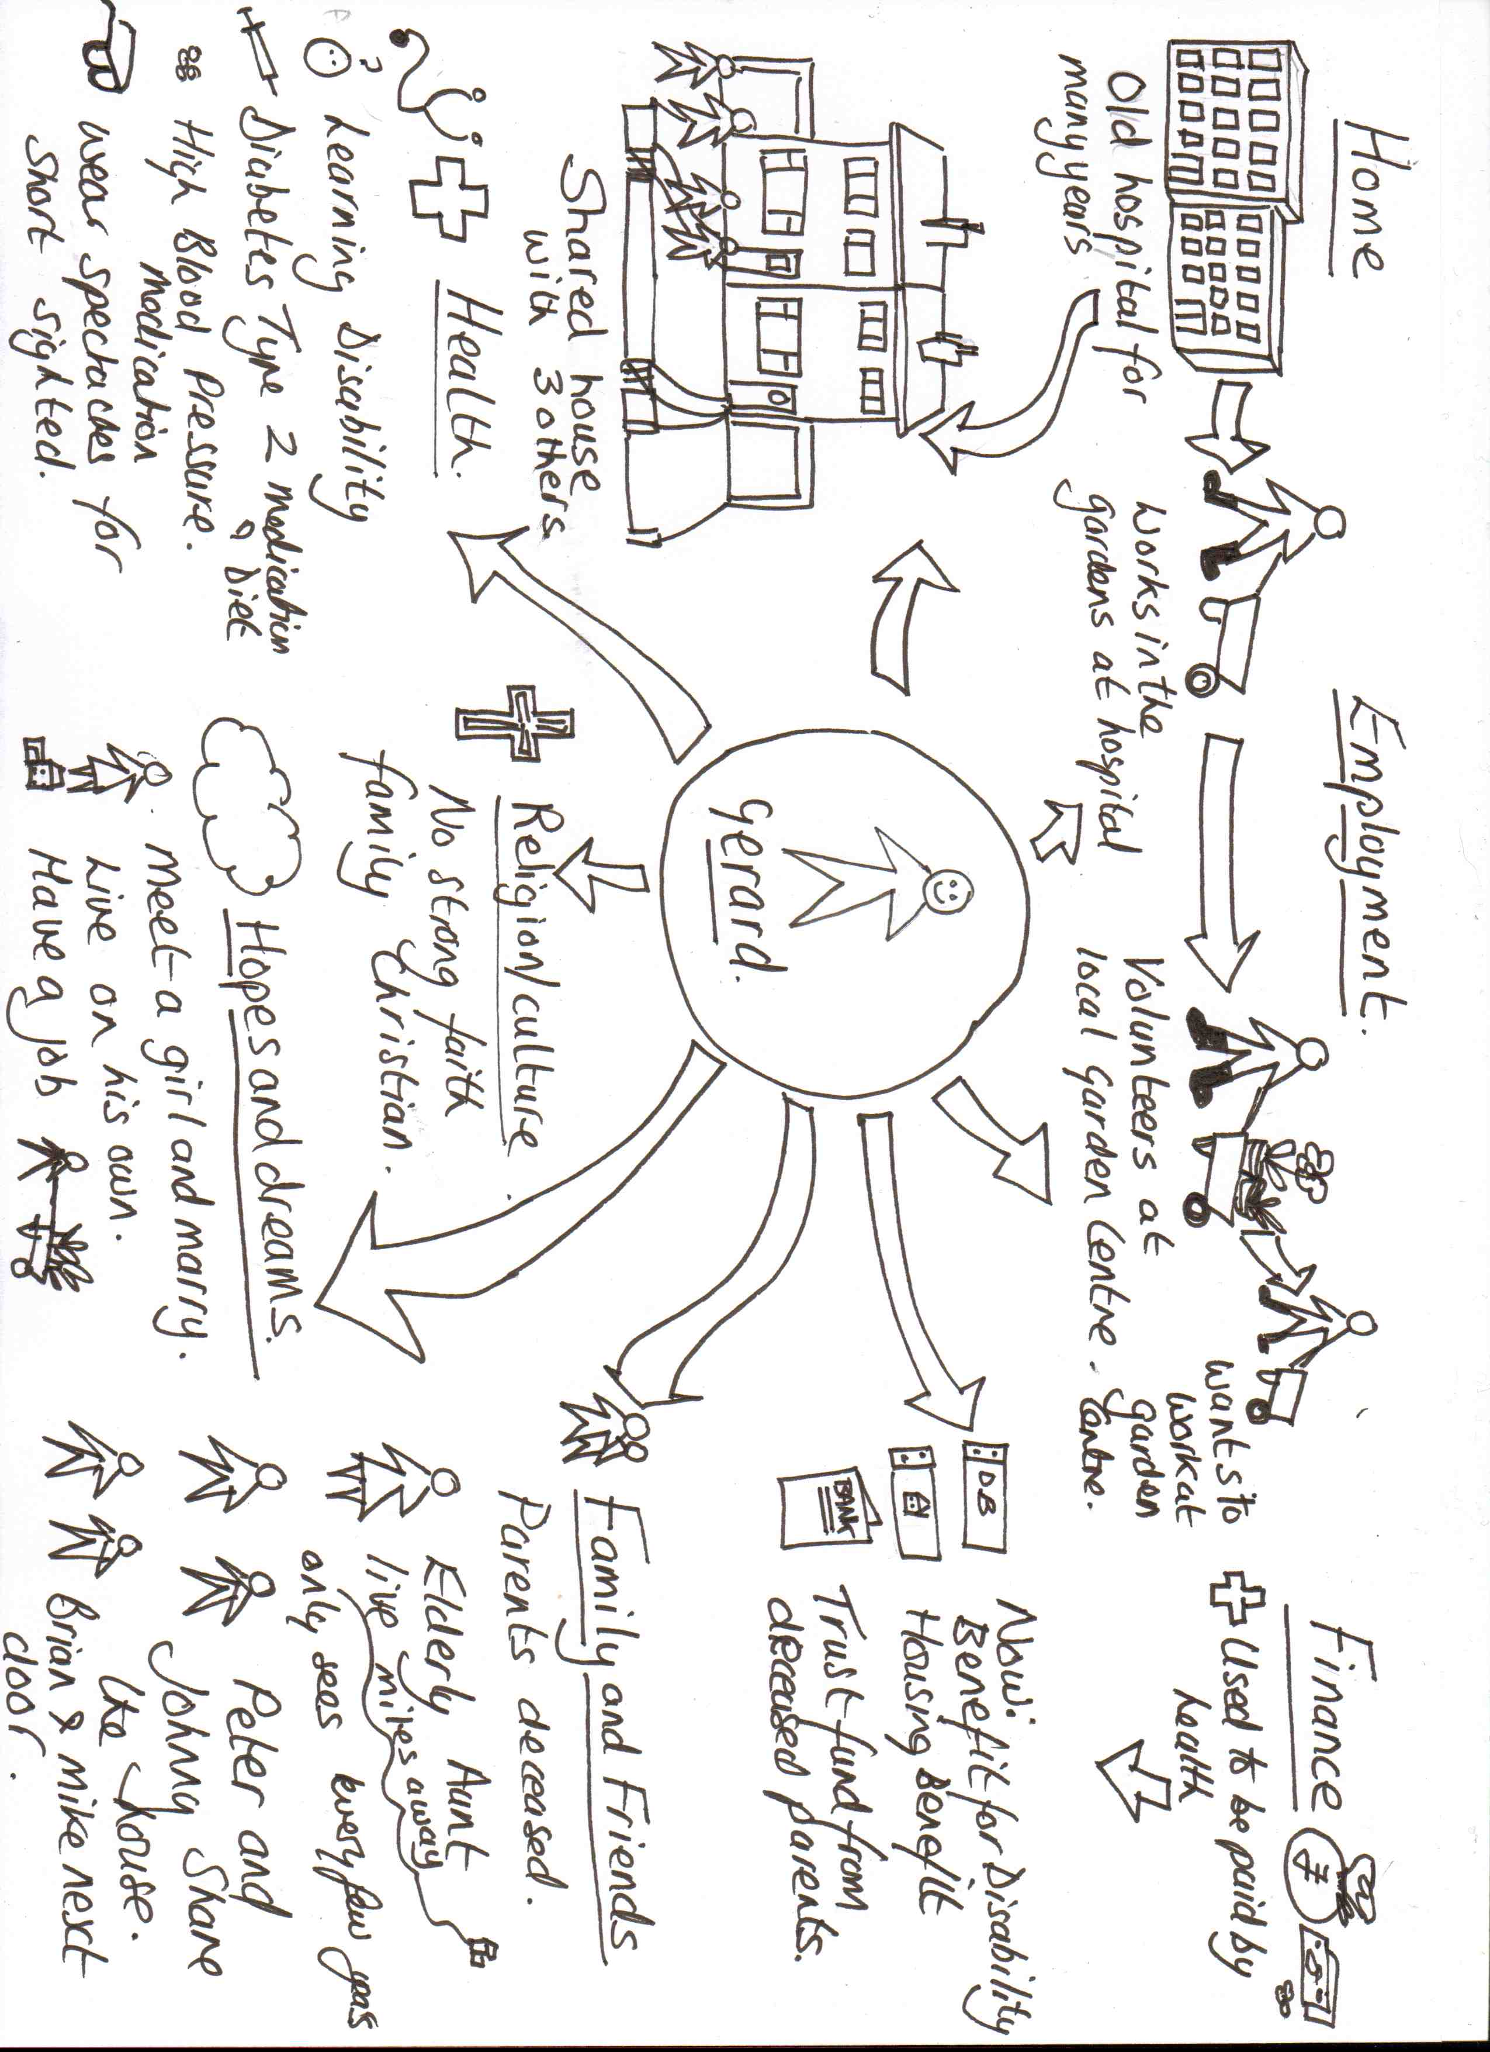

BESCLO 3 Working with Risk. Handout 17
Duty of care
When you are supporting or caring for individuals, you have a duty to ensure that they do not put themselves in danger, put others in danger or you in danger.
‘Duty of care’ is a responsibility for everyone working or volunteering in a caring or supporting role, this not only includes health and social care workers such as yourself but also nurses, therapists, doctors, teachers, youth workers, club leaders (e.g. scouts, guides and brownies), and the police, etc. The main reason that ‘duty of care’ is so important is in ensuring the safety of the individuals and those around them.
To empower the individuals that you support to make choices you need to be sure that they fully understand the consequences of those choices.

Often the choices that we make can involve risks, by risks we mean the possibility of someone or something being hurt or harmed; this can be both physical and/or emotional harm.
The individuals can only really understand about taking risks if they understand the consequences of taking the risks. We do this by completing risk assessments and involving the individuals we support in this process.
To maintain duty of care you should:
- Keep your knowledge and skills up-to-date
- Provide service at a standard that any reasonable person would expect
- Know what you should do to ensure that the service you provide is provided
safely
- Keep accurate records as required by your employer
- Only delegate work or accept it when it is safe to do so
- Protect confidential information except where it conflicts with public interest
or safety.
Dilemmas that can occur
When you are looking at your responsibilities regarding your duty of care, and you are empowering the individuals that you work with to make their own choices and decisions inevitably conflicts are going to happen. Especially if an individual that you are supporting chooses to do something that you feel will put them in harm or danger! The difficulties arise when the individuals we are supporting make choices that you do not agree with. This may be because it is a choice that you feel is wrong, or something that you may feel will put them in a position where they may get hurt emotionally or physically.
Conflicts and dilemmas come into all aspects of our lives not just at work. Difficulties arise when you are not confident that the individual making the decision fully understands the consequences of that decision. It is your role to ensure that you communicate in whatever way is required to support the individual to fully understand the consequences of decision-making.
BESCLO 3 Working with Risk.
Handout 18
What is a risk assessment?

When you complete a risk assessment you look at all of the hazards (all of the things that may cause harm), then you work out how bad they are and then look at ways of making them not as bad.

When you complete a risk assessment you ask your self:
- How serious is the possible harm?
For example, on crossing a road there is a possibility of being hit y a car. The possible harm from this is serious, therefore, the risk is high.

- How likely?
Here you think about how likely it is that the harm may occur. In crossing the road, for example, the likelihood is going to be high if the road is a busy one: if it is a quiet country road the likelihood is going to be lower.

- Can I reduce either of these?
If both the risk and likelihood are high then it may not be worth taking the risk, unless you can look at ways to reduce either of these. Returning again to the example of the road, you can reduce the risk of being hit by a car by ensuring you use a zebra or pelican crossing. The greater the harm and the greater the likelihood, the greater precautions are needed.

- Is it still worth taking the risk?
Once you have looked at the seriousness and likelihood of harm, the precautions you can take and the benefits of taking the risk, you need to decide whether the risk, even with the precautions in place, is still too high to take.
Past experiences may provide some sort of guide about likelihood of harm occurring. This may involve reading an individual’s file, and talking to them personally. Other people who know them well – either family members or professionals may also be able to advise. Where you do not have this information available, you may have to test out the situation, with careful observation of what happens.

It is also important to consider the seriousness of the possible consequences. Could the same outcome or objective be achieved by undertaking a less risky activity; could it be broken down into smaller steps, could others be involved?

Finally, where risks are involved in undertaking a particular activity, it must be decided how important the activity is – is it just something the person thinks they would like to do, or is it seen as a significant part of their development? To what extent does the individual concerned value the activity, or is it something staff

BESCLO 3 Working with Risk.
Handout 19
What do you need to think about when assessing risk?
As a health and social care worker you have a responsibility to analyse risk and minimise the dangers involved for those individuals you work with. There may be different ways in which this can be done, and your organisation may have detailed guidelines. However, the principles of risk assessment should include:

- Assessing and recording the possible hazards this will include looking at the nature and level of risk and the severity of potential harm to all those who might be involved.

- Discussing any risks with the individual concerned and helping him/her to understand them (and where appropriate with their family or advocate). This might include making a judgement as to the individual’s ability to make decisions.

3. Checking carefully what happens in order to monitor the effects of taking the risk so as to:
Judge and note for future reference if the risk was, in fact, too great consider other ways of achieving the same end, or think of any adaptations that could be made.

4. Identifying the form that possible harm may take, which is often the first step in preventing it. This may include:
physical harm to the individual or others distress, annoyance, anger or embarrassment to the individual or others social sanctions which may be applied by family, friends or members of the public damage to property.

Recording and reporting decisions about risk taking
Recording and reporting your decisions is essential because:
• it ensures all concerned know what is happening and why, both for present and future events where different staff may be involved;
• it ensures that your line manager or senior staff know the decisions you have taken and why;
• it enables you to plan support and training if required, prior to undertaking the activity, during the activity and afterwards
• it also aids planning any future events that involve risk.

Wherever possible, decisions involving risk or conflicts / dilemmas should be made in the context of person-centred plans. They should include the individual concerned and any others who might become involved. It is particularly important to liaise and communicate with families about what you are trying to achieve and how you are setting about it! Always record accurately what has happened and think carefully about what support you will receive if things go wrong!
Never plan to go it alone!

BESCLO 3 Working with Risk.
Handout 20
Age of a person
0 10 20 30 40 50 60 70 80 90

This is the shape of support for a person with a disability, they start needing support and this doesn’t taper very much as they need support
ThitThis is the average pattern for an older person , as the get older their independence decreases and the more support they need.

This is the pattern for a average person they start as a baby needing complete support and have no independence but by the time they get to their early 20’s they are independent and need no support.

How much support a person needs or their level of independence

BESCLO 3 Working with Risk.
Handout 21

Age of a person
0 10 20 30 40 50 60 70 80 90

On this diagram the person with disabilities has had risk assessments completed and support put in place so that their level of independence has increased with age (similar to the average person until following the usual ageing pathway at 70 years when the level of support increases again

How much support a person needs or their level of independence

BESCLO 3 Working with Risk.
Handout 22 and 23
Sample Risk Assessment template
How serious is the possible harm?
Here you are considering how serious the harm could be if something happened, scoring 1 to 10, 10 being the most serious of all
How likely?
Here you think about how likely it is that the harm may occur.
Scoring 1 to 10,10 being the biggest impact of all.
Plot the scores on the graph below:

LIKELIHOOD
I
M
P
A
C
T

10
9
8
7
6
5
4
3
2
1

1 2 3 4 5 6 7 8 9 10

BESCLO 3 Working with Risk. Handout 23
When you have plotted the impact and likelihood on the graph using the key below look at what it tells you about the risk:
If the risk is in the :
- High impact and high likelihood (Checked area)
In this area actions MUST be taken to reduce the risk, if the actions cannot reduce the impact or likelihood significantly then the activity should not take place
- High impact or high likelihood only (Stripped area)
In this area also action is needed to reduce the likelihood or the impact. Then a decision can then be taken as to if the activity can take place.
- Low impact and low likelihood (Plain area)
In this area are at much lower risk, you can consider actions to reduce the risk. The activity could then probably take place.

You then finally ask your self with the actions that you have taken to reduce the risk ‘Is it still worth taking the risk?’
Once you have looked at the seriousness and likelihood of harm, the precautions you can take and the benefits of taking the risk, you need to decide whether the risk, even with the precautions in place, is still too high to take.

REMEMBER: all risk assessments must be recorded and signed and dated.

BESCLO 4. Understand your role as a support worker
Handout 24 to 27
ADD Legislation and Guidance supporting working in Health and Social Care.

BESCLO 4. Understand your role as a support worker
Handout 28
Understand your role as a support worker
It is important to understand how each of the areas covered in this section impact on your role. Look at the table below:

Legal – Statutory framework, laws of the land, codes of practice

Local regulations, policies and procedures in your area

Employer’s aims, objectives and values

Job description – what you are contracted to do as a job of work

Individual care or support and packages for
the people that you work with

YOU doing your job

BESCLO 4. Understand your role as a support worker

Handout 29 to 31
Partnership working
In your life you will have many and varied relationships with other people such as
relatives close and distant, friends, colleagues, professionals (doctor, dentist, optician, solicitor etc.), partner, neighbours, etc. The relationship changes dependent on who it is and also the setting and the roles of those involved. In your role as a health and social care worker you need to be aware of all the different types of relationship that you will have during your working role. Understanding how each of these work and knowing what your responsibilities, boundaries and limitations are with each of these.
This training package is designed to help you see the work that you do and the individuals that you work with in a wider context.

It is about helping you develop your understanding so that you can see how the work that you do is part of the broader picture of welfare and the service provision of individuals you support.

It is about ensuring that you see the individual who you work with in a broad context that includes:
- Their history and previous life
- Their achievements
- Their abilities
- The family background
- Their ethnicity and gender
- The nature of their problems or disabilities
- The discrimination they may face.
Whether you work in a registered home, a day centre, in someone’s own home, or as a personal assistant in the support that you offer the individual there is a common thread linking them all – it is done in a face-to-face way with the individual and involves you developing some sort of relationship.

We want to make you think about the nature of the relationships you have with the individuals that you are working with.
A relationship does not have to be complicated; it is simply what goes on between two people and can take many different forms. During the course of our lives we have many different relationships and some are more permanent or important to us than others.

In some of our relationships we make a very big emotional investment, in other relationships we invest very little at all. The relationship that you have with your parents, children or partners in adult life is quite different from the kind of relationship that you have, say, with your next-door neighbour, or the people at the corner shop where you have been shopping for years. Sometimes a relationship might be fleeting. You might go into a shop and purchase a pair of shoes from the sales assistant and never see them again. You might have been going to the same GP for many years. You do not expect the same things from your relationship with all these different people and there are both cultural norms and legal safeguards to protect us if the relationship becomes, feels, or is inappropriate.

It is important to always remember that you are not usually the only person involved in offering support to the individual that you work with. There are often many other people involved with that individual and it is important to stress the need to work in conjunction with all these other people and not to go off at a tangent in the way you offer someone support. You will be called on to share:
• information with other professionals
• decision making.

When working with fellow professionals you must:
- Observe professional boundaries (do not try to do someone else’s job!)
- Share information on a ‘need to know’ basis
- Do not let how you feel about the professional affect your relationship with them
- Don’t collude to exclude the individual/s you are supporting

Working with families, friends and advocates
Leaving aside the need for you to understand the role of the other people paid to support the individual(s) you work with, there is another challenge. It is vital for you to think about the role of families, friends and advocates in relation to the lives of the individuals you are working with.

Even if you are working with individuals who have little or no contact with families, the notion of family and friendship is still important. You might find yourself trying to promote contact with families and friends for the sake of the individual you support, as they want to re-establish contact. Or you might find yourself having to work with the fact that an individual feels animosity towards, or feels abandoned by and at a loss in relation to their particular families.

Remember, this is potentially a very sensitive area when you ask an innocent question you might get more than you bargained for in the reply! If that happens, don’t worry, but do talk to your manager or employer and do think about what it means and how it should affect the way you work.

Don’t forget to include families/carers/friends/advocates and the individuals you support in any Induction activity as much as possible. Remember, they are the real experts and you have most to learn from them and most to lose by ignoring them.

You should never underestimate the importance of family, carers and friends in the lives of the individuals you work with. However, there may also be other significant people, e.g. family friends, advocates or others with whom the person you support has developed a close relationship.

The role of a ‘friend’ may well straddle that of family member, advocate or paid carer. Friends are people we enjoy spending time with, whom we share interests and, at times, problems and who we hope will speak up on our behalf if necessary.

Working with colleagues
Understanding the responsibilities and limitations of your relationship with the individuals that you support.
You will soon become aware that all relationships have boundaries. Your employer may well have laid down ways of working, which describe some of these, for example:
- You must not have a sexual relationship with an individual using your service
- You must not accept expensive gifts
- You must not accept personal help or support form individuals using your service
- You should not pass on information inappropriately to other professionals, colleagues, family friends and advocates etc
- You must not get together with colleagues to exclude the individuals using your service

Teamwork
Teamwork is important when working in any job, but particularly when you are supporting others, as it emphasizes cooperation, working together and supporting each other to ensure you provide the best service you can to those who you support. Teamwork in an organisation can also improve quality, flexibility, coordination, work satisfaction and development.
It is fun to be part of a team and it can help in reducing any tension and/or conflict within your service or setting. But teamwork doesn’t just happen it has to be developed, it requires people to work together to meet their common goals. This may be about deciding how the workload is divided between staff, or ensuring there is adequate staff cover for all shifts.
To ensure good teamwork there needs to be open communication, flexibility,
support and understanding.

The importance of being reliable and dependable
Whatever the job you are doing, reliability and dependability are important qualities to an employer, but when you are working in the health and social care sector and individuals are depending on you to ensure they get the service that they need, it is even more important. Health and social care employers need staff that they can rely on to be at work on time, alert and ready for their shift, because the people you are working with are often reliant on your help to meet their basic needs.

BESCLO 5. Safety at work.
Handout 32

ADD IN laws and guidance surrounding Substances that may be hazardous to health are:

BESCLO 5. Safety at work.

Handout 33
Moving and handling tips and techniques.

Safe lifting
- check your clothes and shoes will not hamper you

- check the area is free from obstruction and the floor is clear and not slippery

- only lift a load that is in your capacity, do Not over stretch your self

- feet should be with the load between them. The lead foot pointing in the direction that the load is being moved

- keep the back straight. Arms close to the body, chin tucked in, bend the hips and knees

- keep the elbows inside the thighs, take hold of the load with one hand at the upper corner over the leading foot and the other in the lower opposite corner

- lean forward a little, keep the rear arm straight, and tilt the load forward ands in one smooth movement stand up. If you turn, turn with your feet do not twist the body

- to lower reverse the procedure bending hips and knees

- lifting from a platform or bench, use the same way of lifting but remember to bring the load firmly into contact with the body.

It is essential that you understand that you MUST NOT complete moving and handling tasks until you have completed the correct training.

BESCLO 5. Safety at work.

Handout 34
Fire safety
Although it is not obvious, what is actually burning in a fire is not a solid but the vapour released from the solid fuel when it is heated. These burning vapours then heat the solid fuel more, which in turn releases more vapours.
Fire requires three conditions to survive or spread:
• heat
• fuel
• oxygen

If any of these is reduced or removed a fire will reduce or cease.
Fuel that is spread thinly such as paper ignites and burns more fiercely than thick layers of fuel such as a book.
Fire spread and grows quickly in an enclosed space, much stronger than most people will ever experience in a household coal fire or bonfire.
If you understand the mechanics of fire you will be able to better respond quickly.
At its worst fire can kill and it can do so quickly, silently and with out warning. For these very reasons you need to understand how fires are most likely to start in your work place, what you can do to prevent it and do if you ever encounter it.
As the temperature in a room rises, more and more items reach a temperature at which vapour is released and can ignite. ‘Flashover’ in a room is when the temperature has reached a point where virtually all items have released vapour that can ignite.
You should know where the following are in your workplace:
- Fire alarm system
- Emergency lighting
- Fire doors
- Fire exits
- Fire fighting equipment

BESCLO 5. Safety at work.
Handout 35

Fire sources
Common sources of fire are:
- Electrical faults e.g. faulty wiring on electrical appliances or sockets
- Cooking e.g. people leaving fat or oil or other flammable liquids on an open flame
- Smoking e.g. cigarette stubs, hit ash or matches failing onto bedding, sofas, clothing or carpets
- Chemicals e.g. storing paint cans, oily rags, petrol or other flammable liquids in a closed environment where they may overheat or catch a spark
- Candles especially if left unattended
Keeping safe-There are some routine checks that should take place last thing at night or before leaving a building for any length of time. These are:
- The cooker is turned off
- Nothing has been put on the hob
- Electrical appliances are off and un plugged
- Heaters are off
- Fire guards are in place
- Ash trays are empty
- Smoke alarms are in place and batteries have been checked
- Candles are correctly extinguished
A problem for those providing services is how you can ensure a safe environment whilst still ensuring it is a ‘home’. You must also ensure that those using the service are aware of fire safety procedures.
All workplaces will have fire alarms in place and clear ‘ways of working’ about how to deal with emergencies in particular fire safety.
These will include fire alarms, fire drills or practices, so that everyone knows what to do in the event of a fire.

BESCLO 5. Safety at work.

Handout 36
What if there is an accident or sudden illness?

Accidents can happen anywhere and to anyone. Many are preventable and can be as a result of someone being careless or unaware of hazards.
But what will make it easier and better for everyone will be if you know how to respond to an accident or sudden illness. However you need to be clear about what your limitations and responsibilities are when dealing with an emergency.

Thinking about the different types of accident and sudden emergency that could occur:

- Fire
- Someone could fall
- Someone could have a sudden illness such as a heart attack
- Gas leak
- Power cut
- Flood
- Road Traffic Accident
- Missing person
- Bomb scare

BESCLO 5. Safety at work.

Handout 37 to page 54
Basic First Aid Techniques
To comply with Health and Safety (First Aid) Regulations, employers have to make sure that they and their staff are prepared for accidents and emergencies and have adequate first aid provision.
Most cases of first aid do not involve life threatening situations. In all cases of first aid your aim should be to give prompt and correct treatment. To do this it is useful to have a prepared mental plan to follow at a time that is likely to be traumatic and when others will need you to be calm.
Listed below is a checklist (sometimes called a ‘Primary Survey’) of the things you need to do in an emergency.
Check for DANGERS – are you or the casualty in any danger?
For example, are there electric cables near or under the casualty? Have they been electrocuted? You should assess the situation and, if you have not already done so, make it safe (e.g. turn off the electricity). Make it safe for:
• yourself
• others
• the casualty.
Remember, you cannot help others if you become a casualty.
Check for a Response – is the casualty conscious?
If the casualty appears unconscious, check this by shouting.
• Ask, “Can you hear me? Open your eyes.”
• Gently shake their shoulders (do not move head or neck).
If there is A RESPONSE and there is no further danger, leave the casualty in the position found and summon help if needed. Treat any condition found and monitor their vital signs (level of response, pulse and breathing). Continue monitoring until help arrives or the casualty recovers.
If there is NO RESPONSE, shout for help (three times) then follow the ABC procedure below.
ABC procedure
A – Airway
If possible leave the casualty in the position found and open the airway. Open the airway by placing one hand on the casualty’s forehead and gently tilting the head back. Lift the chin using two fingers only. This will move the casualty’s tongue away from the back of the mouth. Check the mouth for obstructions.

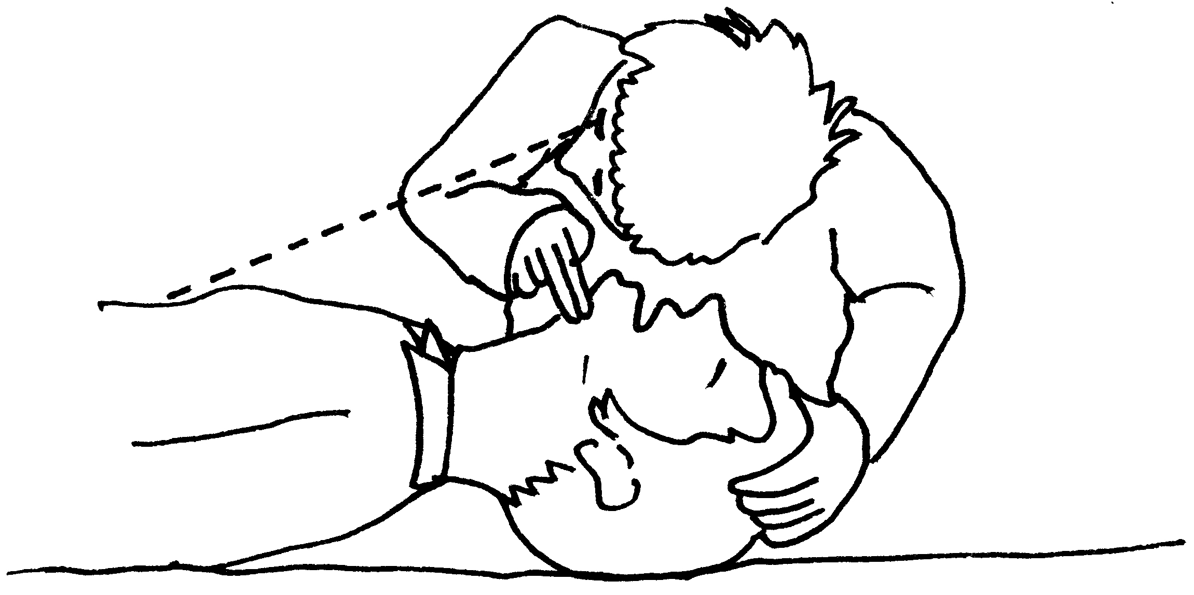
B – Breathing
Spend no more than 10 seconds checking to see if the casualty is breathing
normally:
• Look to see if the chest is rising and falling, listen for breathing.
• Feel for breath against your cheek.
If they are breathing normally, place them in the recovery position
( See on page 30 )

• Check for other life threatening conditions, e.g. severe bleeding and treat as necessary.
Agonal Breathing: This is common in the first few minutes after a sudden cardiac arrest. It usually takes the form of sudden irregular gasps for breath. It should not be mistaken for normal breathing and if it is present chest compressions and rescue breaths should be started without hesitation.
C – Circulation
Spend 10 seconds checking for signs of circulation, feel for pulse at neck or wrist for at least 10 seconds, look, listen and feel for breathing, coughing, movement or any other signs of life.

Cardio-Pulmonary Resuscitation (CPR) – Adult
• If you have someone with you, send them to Dial 999 (or 112) for an ambulance immediately. Ask them to return to let you know they have phoned
• If you are alone Dial 999 (or 112) for an ambulance immediately and then return to help the casualty.
Give 30 Chest Compressions
• Place heel of your hand in the centre of the chest
• Place other hand on top and interlock fingers
• Keeping your arms straight and your fingers off the chest, press down by 4-5cms; then release the pressure, keeping your hands in place
• Repeat the compressions 30 times, at a rate of 100 per minute.
Give 2 Rescue Breaths
• Ensure the airway is open
• Pinch nose firmly closed
• Take a deep breath and seal your lips around the casualty’s mouth
• Blow into the mouth until the chest rises
• Remove your mouth and allow the chest to fall
• Repeat once more.
Continue resuscitation, 30 compressions to 2 Rescue Breaths
Do not stop unless:
• emergency help arrives and takes over
• the casualty begins to breathe normally, or
• you become so exhausted that you cannot carry on.
Notes
• If you are alone, call an ambulance as soon as you know the casualty is not breathing – unless unconsciousness is due to drowning (whereby you should give FIVE initial rescue breaths and perform CPR for one minute before making the call).
• If two rescuers with the knowledge of CPR are available, change every two minutes with minimal disruption.
• If you are unable or unwilling to give rescue breaths, give chest compressions only. Continue at a rate of 100 per minute.

CALLING THE EMERGENCY SERVICES.
Call the emergency services number
999 or 112
Request the ambulance service and any other services that may be required.
Remember you will need to give them as detailed information as possible:
- About where you are, try to have the road name, if you do not know it give local landmarks so your location can be identified, try to ask someone who is passing by
- About the casualty, their injuries and symptoms and any first aid you have administered
- They may also want a contact number so they can call you back if the connection is broken
- They may also wish to know your name as well

Recovery position
An unconscious casualty, who is breathing, remains at risk of an obstructed airway unless he or she is placed in the recovery position.
This involves lifting the chin forward to keep the airway clear and open, and ensuring the head is lower than the body, so fluids will drain out of the mouth and are less likely to be inhaled. The hands should support and protect the head, the arm and leg bent to make the position more stable and stop the body rolling forward (as below).
• Turn the casualty onto their side.
• Lift the chin forward in an open airway position and adjust hand under the cheek as necessary.
• Check casualty cannot roll forwards or backwards.
• Monitor breathing and pulse continuously.
• If injuries allow, turn the casualty to the other side after 30 minutes.
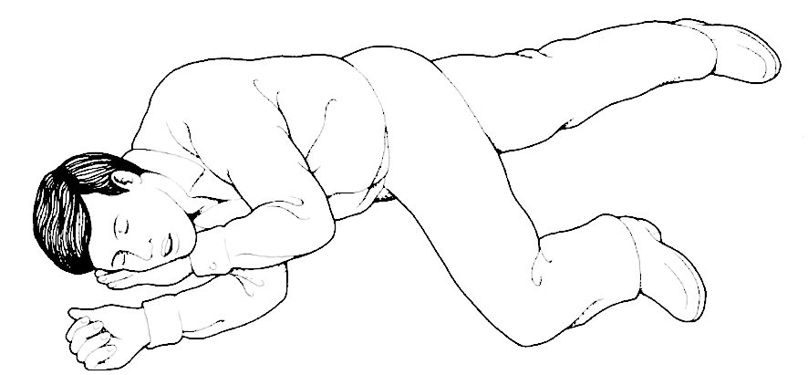

Rescue breaths
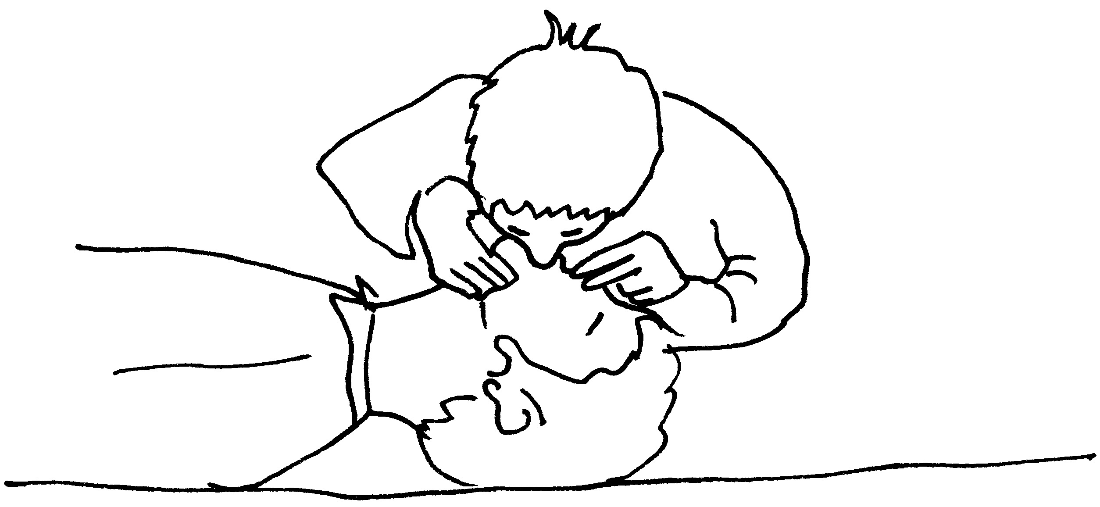
Chest compressions
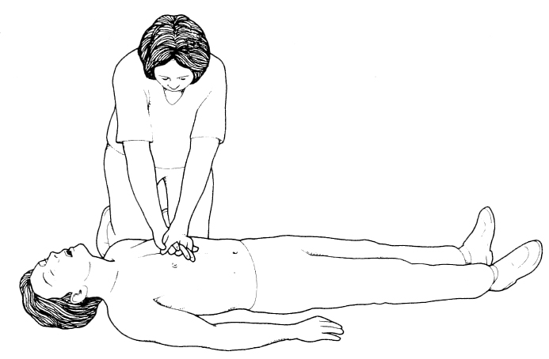
Note: You should not attempt to practice resuscitation on a colleague, only on a resuscitation mannequin!
If the casualty is breathing and has a pulse, check for bleeding.
Bleeding
If you find a person who has serious bleeding, this requires immediate treatment to save their life. External bleeding is usually easy to see, however, internal bleeding may only be noticed if the person shows signs of shock (page 8/23). The aim is to control the bleeding and to keep the wound clean and infection free.
If you are in a situation where you have to deal with severe external bleeding you should:
• apply direct pressure to the wound with a pad (e.g. clean cloth) or fingers until a sterile dressing is available
• if it is an injured limb raise and support it (taking care if the particular limb has a suspected broken bone)
• lay the casualty down, lifting the legs slightly to treat for shock, bandage the pad or dressing firmly to control the bleeding (checking that it isn’t so tight as to stop circulation to the fingers or toes). If bleeding seeps through the first bandage, cover with a second bandage. If bleeding continues to seep, remove and reapply a new bandage.
• call an ambulance.
The wound that is most likely to feature severe bleeding is the incised wound, caused by a sharp object such as a knife.
You can protect yourself from infection by:
• covering any open wounds you may have (cuts, grazes, broken skin) with a waterproof dressing
• wearing disposable gloves, if possible, when you are dealing with a bleeding casualty.
Dressings are used to cover wounds; they:
• help control bleeding
• protect from further injury
• prevent infection.
If a bandage is too tight it impedes the blood circulation. The tissues beyond the bandage cannot receive sufficient oxygen and may become damaged or destroyed. You know a bandage is too tight if you observe these signs or symptoms:
• skin is pale or blue-grey in colour
• skin feels cold to touch
• casualty reports tingling or numbness of the part
• casualty develops inability to move the part.
To make sure that the bandage securing a dressing is not too tight:
• check immediately after bandaging (by feeling and looking for the signs and symptoms and by pressing a finger/toe nail bed until it is pale, then releasing it and noting the return, or absence, of colour)
• then check for signs every 10 minutes
• loosen the bandage if circulation is cut off, but monitor carefully in case bleeding starts again. (You will have to retie it to make it firm again once circulation is restored.)
REMEMBER – your priorities will be to control bleeding and prevent infection according to the risks.
Minor cuts, scratches and grazes
• Wash and dry own hands and cover any cuts or open wounds on your own hands and put on disposable gloves.
• Clean the cut, if dirty, under running water. Pat dry with sterile dressing or clean lint free material. If possible, i.e. if it is a limb, raise affected area above the level of the heart.
• Cover cut temporarily while you clean surrounding skin with soap and water and pat the surrounding skin dry. Cover the cut completely with sterile dressing or plaster.

Objects in wounds
Where possible wash or swab small objects out of the wound with clean water. If there is a large object embedded:
• leave it in place
• apply firm pressure on either side of the object
• raise and support the wounded limb or part
• lay casualty down to treat for shock
• gently cover the wound and object with a sterile dressing
• build up padding around the object until the padding is higher than the object, then bandage over the object without pressing on it
• depending on the severity of the bleeding, dial 999 for an ambulance or take the casualty to hospital.
A good guideline to remember is:
• severe Bleeding – priority is to CONTROL BLEEDING to minimise SHOCK
• slight Bleeding – priority is to MAINTAIN CLEANLINESS to minimise INFECTION.

Shock
In the case of a serious accident you need to watch out for the signs of shock.
These are:
• pale face
• cold clammy skin
• fast shallow breathing
• rapid weak pulse
• yawning
• sighing
• in extreme cases unconsciousness.
The treatment for shock is:
• lay the casualty down, raise and support their legs
• use a coat or blanket to keep them warm (but not smothered)
• do not give them anything to eat or drink
• check breathing and pulse frequently. If breathing stops follow the resuscitation sequence
• give lots of comfort and reassurance.

Burns and scalds
Burns are generally caused by dry heat, electricity, friction, or corrosive chemicals. Scalds are caused by moist heat (e.g. boiling water).
The pain may be intense, especially with superficial burns. There is usually redness, and blistering often occurs later. There is usually a great deal of shock.
Severe burns and scalds:
• start cooling the burn immediately by immersing the injured area in cold water or place under slowly running water for at least 10 minutes. This decreases the spread of heat and alleviates the pain. However, too long under cold water may induce hypothermia (excessive cooling), so be careful with large or multiple burns
• dial 999 for an ambulance
• whilst wearing disposable gloves remove anything that constricts (e.g. rings, clothing, or shoes) before the burned area begins to swell; unless it is sticking to the skin
• cover burn with clean, non-fluffy material to protect from infection. A clean plastic bag or kitchen film make good dressings
• treat for shock.
Do not apply any lotions or ointments.
Do not prick blisters.
Do not breathe over, cough over, or touch burned areas.
Do not use adhesive dressings.

Minor burns:
• hold affected area under cold water for at least 10 minutes or until pain subsides
• remove jewellery, etc
• cover the burn as above.
If the minor burn is larger than a postage stamp it requires medical attention. All deep burns of any size require urgent hospital treatment.
Do not apply any lotions or ointments.
Do not prick blisters.
Do not breathe over, cough over, or touch burned areas.
Do not use adhesive dressings.

Clothing on fire:
• stop casualty panicking or moving about (any breeze will fan flames)
• drop casualty to the ground
• if possible, wrap tightly in a coat, curtain, blanket (not nylon), rug or other heavy duty fabric
• roll the casualty on ground until flames are smothered.

Fractures
• Give comfort and reassurance
• ensure casualty stays still
• do not move casualty unless you have to
• steady and support the injured limb with hands to stop any movement
• if there is bleeding, press clean pad over wound to control blood flow (see bleeding section above) then bandage around the wound
• if you suspect a broken leg put padding between knees and ankles. Form a splint (to immobilise leg further) by gently but firmly bandaging the good leg to the bad one at the knees and ankles, then above and below the injury
• if it is an arm that is broken, improvise a sling to support the arm close to the body
• dial 999 for an ambulance
• if it does not distress the casualty too much raise and support the injured limb
• do not give the casualty anything to eat or drink in case an operation is necessary
• watch out for signs of shock
• if the casualty becomes unconscious follow the resuscitation sequence.

Choking
A foreign object that becomes stuck at the back of the throat may either block the throat or bring about a spasm of the muscles. This is choking. Adults may choke on food that has not been chewed well enough or swallowed too quickly. If you find someone choking, you need to respond quickly and be prepared to resuscitate if the person stops breathing.
Signs of choking are:
• the person has difficulty in speaking or breathing, their face becomes contorted
• their skin may change colour.
When responding to a person who is choking you should be aiming to remove the obstruction so that they can breath normally again.
• ask the person to cough, to see if the obstruction can be moved naturally, but do not spend a lot of time on this
• bend them forward, give up to 5 slaps between the shoulder blades with the flat of your hand.
If the choking persists:
• stand behind the person and put one hand, curled into a fist below their rib cage
• link your hands and pull sharply inwards and upwards
• continue alternating 5 back slaps and 5 abdominal thrusts until the obstruction clears.
If the person is NOT conscious, you may find that the muscle spasm is relieved. However, if you are unable to ventilate them by slapping their back, alternate this method with resuscitation. Check the mouth and use a finger to hook out any obvious obstruction. If at any stage the person begins to breathe normally, place them in the recovery position and call for an ambulance.

Seizures or convulsions
A convulsion or seizure consists of involuntary contractions of many of the muscles in the body, caused by a disturbance in the function of the brain. Seizures may be triggered by tumours, head injury, fever, chemical imbalance or stroke, but are most commonly associated with epilepsy which is treated by medication.
Seizures come in a number of forms, some of which are potentially more serious and require immediate action. Some might better be described as ‘absences’, where the person appears to be staring into space, have slight twitching of their eyes, lips or head or odd movements. In these situations all that is necessary is to sit the person down in a quiet place, away from any potentially dangerous objects and reassure them until they recover.
If a person has a major seizure, they are likely to either become unconscious or rigid. Breathing may cease, the lips change colour and convulsive movements begin. There may also be loss of bladder control, saliva appearing at the mouth and noisy breathing. If you have to deal with a person who is found having a seizure:
• protect the person from injury while it lasts
• do not lift or move the casualty unless they are in immediate danger
• cushion their head if they are on the ground
• do not use force to restrain or put anything in their mouth
• make space around the person, if possible support them as they fall and loosen any tight clothing
• when the convulsions have ceased, place in the recovery position, check breathing and pulse and remain with the person until they have fully recovered
• if they remain unconscious for more than ten minutes or convulsing for more than five, call an ambulance.
NB: In some situations, where a person regularly has severe convulsions, agreement may have been reached for support workers to administer prescribed medication (not you yet!). This should only be done by an authorised member of staff who has been trained by a doctor or nurse and with the approval of the inspection unit. If in doubt seek medical help.

Poisoning or overdose
If the person is unconscious place them in the recovery position and call an ambulance.
If the person is conscious take them to accident and emergency or call an ambulance.
If someone is poisoned or has taken an overdose it is important to have as much information as possible about what they have been poisoned with or taken.
Try to find out:
• what is the poison or overdose they have taken (take the empty container)
• how much has been taken (the container may be of help)
• how long ago it was taken
• if the person has been sick then take a sample of the vomit too, medical staff may be able to analyse it for important information
• it is important that you do not force the person to vomit. Some poisons cause harm as they are vomited out of the stomach, so it is better to have the stomach emptied by hospital staff.

References: This Basic First Aid section was based on information from:
ARC Developing Competence in Care Distance Learning Pack and NHS direct website. For more information www.nhsdirect.nhs.uk
First Aid Advice online-St John’s Ambulance. For more information www.sja.org.uk
NHS direct website for more information www.nhsdirect.nhs.uk
This information was up to date at the time of publishing, however First Aid guidance and best practice is sometimes updated, we endeavour to keep our materials updated regularly.

BESCLO 5. Safety at work.

Handout 55 and 56

Infection control
When groups of people live together, infections can spread very easily. How often has someone in your family or your workplace gone down with a cold or flu and within a few days has passed it on to someone else?
Infections that can be spread from one person to another are described as communicable infections. Infections can be spread in a variety of ways and it is important that you understand this to ensure that you work safely.
Communicable infections are; Measles, mumps and chicken pox. Some are more serious than others such as Hepatitis B and HiV (Human Immuno Deficiency Virus), it is important you understand how infections are spread so that you can work safely.

How infections spread
Infections are spread by micro organisms which are found in the air, on skin, in food and on everything that we touch. Some micro organisms are harmless these are called non-pathogenic, the ones that are harmful are called pathogenic.
These pathogens spread through:
- Open wounds
- Inhalation
- Injection
- Ingestion
Infection can enter the body through broken or damaged skin, membranes in the eyes, nose and air passages, through eating contaminated food or drink, sexually transmitted.
If you have an infection it can cause; fever, restlessness, pain, lack of appetite, swelling, discharge, vomiting, and diarrhea. These can be mild or severe.

How can you prevent infections from spreading?
Keeping clean, is one of the easiest ways to stop infections spreading, thorough hand washing!

Hand washing

You should wash your hands:
- At the start and end of each shift
- Before and after supporting an individual (even if wearing sterile gloves)
- Between contacts with different individuals
- After using the toilet or supporting toilet activity
- After coughing, sneezing or blowing nose
- Before and after eating, drinking and handling food
- Whenever visibly dirty

Good hand washing technique:
- Wet hands thoroughly under running water
- Apply hand washing agent( soap, gel, anti bacterial wash)
- Distribute thoroughly
- Vigorously rub hands together for 10 to 15 seconds, carefully include all fingers, thumbs, backs of hands and wrists.
- Thoroughly rinse any soap and debris
- Dry hands with warm blow dryer or paper towel ( try to avoid cloth towel as these harbour bacteria and may contaminate your clean hands)

Keep the rest of you clean, maintaining good hygiene standards by:
- Showering or bathing daily
- Keeping hair clean, keep long hair tied back
- Keep nails clean and trimmed
- Wear clean clothing
- Keep jewellery to a minimum
- If you wear a uniform, ensure it is clean at all times

Using personal protective equipment

Personal protective equipment such as aprons, sterile gloves should always be used when handling body fluids and needles. This includes supporting an individual with toileting, menstruation, and handling soiled bed linen or clothing.

You can help to contain infections by covering contaminated wounds with suitable sterile dressings and disposing of contaminated waste material in a special waste bin or bag (these should be provided by your employer).

BESCLO 5. Safety at work.
Handout 57
Security
Taking responsibility for maintain a safe environment is not only about safety inside the building but also about ensuring that the building and property are secure from intruders and other possible dangers.
This could include measures or devices such as burglar alarms, security lighting, secondary locks on windows and doors and procedures for checking the identity of visitors. It is vital that not only you understand the importance of security but also the individuals you are working with.

It is an unfortunate fact of life that nowhere is completely safe. When you work in a place that can have a variety of visitors you need to have systems in place for checking that those people entering the premises are who they say they are. All genuine professional visitors are likely to carry some form of identity or should have made an appointment before hand.

If you wish to check a person’s identity you can take their details and contact the organisation that they work for to check they are who they say they are, you do this before you let anyone into the building.

Your organisation’s ways of working will describe when it is and is not appropriate to pass on written information. Access to records of both staff and individuals using your service should be strictly controlled. It may be easy for you to recognize that you do not pass on personal details to the visiting ‘window cleaner’ however it may be more difficult if the visitor is a relative or professional visiting an individual in your service. You must be clear about the boundaries of confidentiality in such circumstances, remember we covered confidentiality earlier.

BESCLO 5. Safety at work. Handout 58
What to do if there is security threat?
We have covered accidents and sudden illness or emergencies earlier, which included things that may be a security risk such as ; bomb or gunman threat, a person going missing, there could also be an intruder on the premises or you arrive and there has been a break in.
Your workplace should have clear ‘ways of working’ on how to respond to these type of incidents.
However, it is almost impossible for every situation to be considered, as a result there could be an incident that you have not thought of. But providing you have considered other things you will have those basic skills to know how to respond.

If your employer has ‘ways of working’ for these you must make sure that you know what these are and that you know what your responsibilities are in these situations.
What to do if someone goes missing?
- Check that arrangements to go have not been made
- Speak to everyone present, gathering information about the circumstances around the person going missing
- Tell your line manager
- Check day book, visitors book, appointments etc so you are sure nothing has been overlooked
- Check there is not just a delay in returning from a visits or appointment
- Check there has not been a vehicle break down
- Check for messages
- Ensure all the building is searched
- Search the premises and grounds
Once confirmed the person is missing follow your organisations ways of working, this will probably to contact the service manager, possibly the police NB who calls the police etc.
For this you will need detailed information about the clothing the person was wearing, a photo of the person, favourite places they like to go etc
You will need to remember to record the incident in detail.
If the person has gone missing before check the risk assessments and the persons records for any useful information.

What if there is a bomb scare or gunman threat?
Your local government will probably have procedures in place in how to deal with this. Ensure that your organization is aware of the local arrangements.
However the main point is to ensure that everyone is kept safe and out of any danger.

What if there is an intruder in the building or grounds?
Your organization should have clear procedures for handling this situation which will include, ensuring everyone is safe, and contacting the local police force.

BESCLO 5. Safety at work.

Handout 59

Personal safety and well being
There may be situations in your job role that your personal safety is under threat.
This could be because:
- You are a lone worker
- You have to handle valuables (visiting the bank depositing or collecting money)
- You could have an accident or injury
- You may be at risk of infection
- Working with individuals who may have challenging behaviour
- Using equipment to support individuals e.g. hoist, wheelchair etc
You need to be aware of these risks and ensure that you take precautions to ensure that you are not harmed in any of these situations. You must also ensure you follow your organisation’s ‘ways of working’ (policies and procedures)

Remember it is important in all areas of security to think about the risks involved and ways to minimize risks e.g. to keep a home secure you will have locks on the doors, to minimise the risk further you may also have locks on the windows, reducing risk further you may also have a burglar alarm fitted! Thinking about risk assessments and minimizing risks can help keep an individual and their home safe and secure.

BESCLO 6. Communicating Positively
Handout 60
Motivators to communication
Motivators are the reasons why we communicate.
The communications can be with a wide range of people:
- Partner
- Child
- Friend
- Family member
- Colleague
- Manager
- Professional
- Neighbour
- Service provider i.e. bus driver, postman, shop keeper etc

Types of communication can be:
- A wave
- A conversation
- Just one word
- A kiss
- A brief chat
- A request
- A nod
- A transaction i.e in a shop
- The list is endless

The motivator for the communication can be:
- A need
- A desire/want
- A social interaction
- Stating something
- Making a choice
- Expressing a feeling
- Expressing an idea

BESCLO 6. Communicating Positively

Handout 61
Barriers to communication

There are a range of barriers to communication these can be physical barriers such as:

- The individual is in pain
- The environment is uncomfortable e.g. too hot or too cold
- It is too noisy
- There are many distractions
- The individual cannot hear

There are speech barriers such as:
- The message is not adapted for the individual e.g. language is to complex
- The use of jargon
- The speech is in another language
- The person speaking speaks too fast
- The person has a strong accent or dialect
- The person finds communication difficult

There are other more psychological barriers such as:
- The message is too painful to hear
- The person does not want to listed
- The person giving the message is unclear
- It may be too difficult for the person to respond due to pain, discomfort, communication difficulties
- The person giving or receiving the message has developed barriers to communication based on prejudice and discrimination

Understanding the barriers to communication will ensure that you can break down those barriers to be confident that you can communicate and interact clearly with everyone.

BESCLO 6. Communicating Positively

Handout 62
How to be a good communicator
Working in health and social care you need to be an excellent communicator, if you do not communicate well then misunderstandings can occur which can cause distress, and conflict.

Listening
A way to be a good communicator is to also be a good listener. An important aspect about communication is that it is a two-way process. It involves the speaker and the listener. Remember, it is important to recognise that the term ‘listening’ is not just about receiving sounds, but also about receiving and interpreting the messages we see.
Active Listening
This a structured way of listening and responding to others it focuses the attention on the person speaking.
You stop your own thoughts judgment so that you listen fully to the speaker.
The basic principles to active listening are:
- Taking time and space to listen to the person, stop doing other things
- Concentrate on the conversation avoid all distractions
- Imagine your self in the world of the person
- Look at the facts , think about the emotion of what is being said
- Show that you are interested in a non verbal way; through eye contact, nodding etc
- Let the person finish, don't jump in to fill any silences
- Don't interrupt
- Try to delay your own reaction, don't start to think about what you will say next
- Ask questions, encourage the person to explain in more detail
- Summarise what the person has said in your own word to check your understanding.

BESCLO 6. Communicating Positively
Handout 63
Other ways that can assist with active listening:
- Using exploratory questions such as ‘what do you mean?”, “can you explain?”
- Rephrasing e.g. “have I understood that correctly?”, “Do you mean …?”
- Reflecting back to the person e.g. “You are glad the meeting finished then?”
- Interjecting: e.g. nodding, smiling, say “yes” or “no”
There are barriers to being a good and active listener these are:
- Thinking that you know what the person is going to say before they have said it
- Twisting what they are saying to meet with what you want
- Making a judgment about the individual whilst they are communicating, affects how well you listen and interpret the message
- Being influenced by your own emotions, , sometimes you an misunderstand what is being said because you are already upset or angry and this affects your listening skills.

Research by Albert Mehrabian’s completed in 1971 at California University, Los Angeles. Shows that when some one is communicating the listeners perceptions are guided by only a small percentage, 7%, on the actual words spoken the main guidance is the way the words are spoken 38% and the individual’s body language 55%.
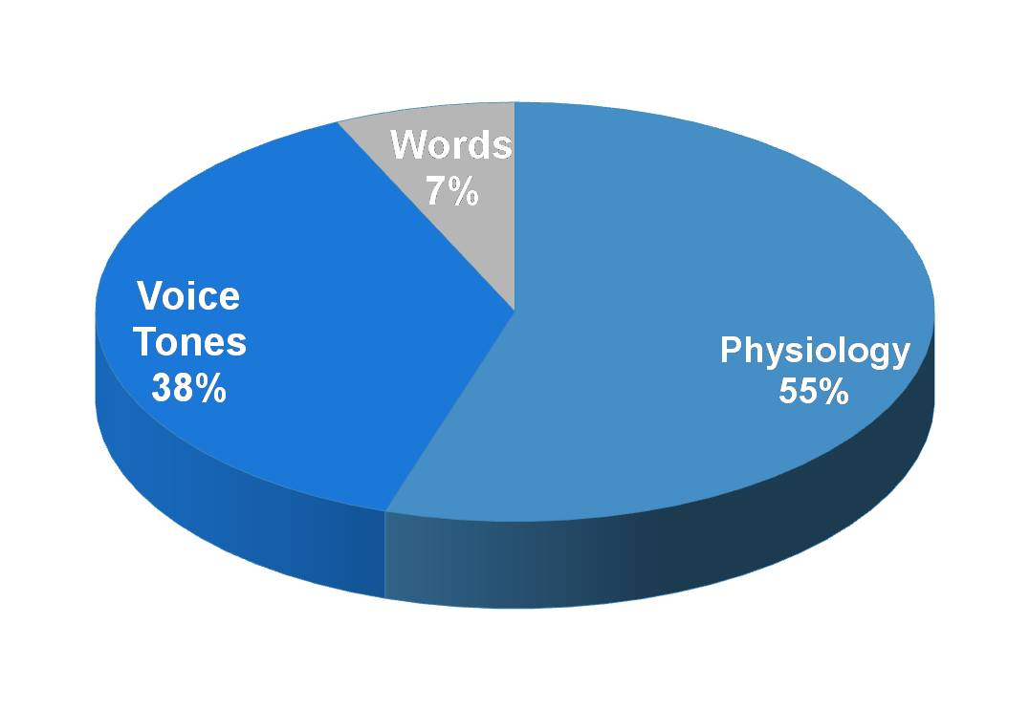

BESCLO 6. Communicating Positively
Handout 64

Verbal and non-verbal communication
Verbal communication is when we use words to express our needs or wants, non-verbal communication is when we give messages by how we act, this can be; facial expression and body language etc.

Think about the verbal and non-verbal communication in the following example:
‘You are very busy but need to support an individual using your service to have a drink, you are busy talking to another staff member about the shift pattern, when mid conversation you break off glance at the individual and quickly ask if they want a drink’
Or alternatively you could:
‘ Stop what you are doing, agree to speak to the other staff member later, sit down and bring your self to the individual’s eye level, look at them, ensuring you have eye contact and ask them at a normal pace if they would like a drink, whilst holding their glass or mug up so that they can see it.’

Which scenario is likely to get a response?

When you are thinking about non-verbal communication you must remember that how non-verbal communication can change dependent on the culture of the individual. This is covered in more detail when we talk about ‘touch ‘ as form of communication in a later section.

BESCLO 6. Communicating Positively

Handout 65
Understanding that behavior is a form of communication
Behaviour is also part of communication and sometimes some individuals can only communicate through their actions especially if they have not got any verbal communication or they find it difficult.
Sometimes behavior as a way of communicating can be seen as challenging, but imagine how frustrating it would be if you desperately needed to tell someone that you were really thirsty and you have no verbal communication, and the staff around you are ignoring you. In this situation you may start making loud noises if you are able to bang a cup or something on the table, staff can often misinterpret this information as being challenging.
Remember that behaviour that is challenging may be a form of communication. This can result in developing conflicts. If an individual has difficulty in communicating their needs, wants and wishes they may try to communicate this in behaviour that can be seen as challenging. If staff fail to notice individuals developing behavior patterns, this can escalate into open conflict. Staff should understand how to notice behavior, which might trigger aggression, and also know how the staff team have agreed what reactions can best divert and defuse the situation.
For example, an individual who has dementia may have problems communicating a need to use the toilet, this may be shown by wandering and refusal to sit down. Or, they may show aggression, as they are unable to express being in pain.
Having covered all of the ways in which you can make communication effective (by taking account of the way the individuals who you support communicate, how settings and social context all influence their communication), you can now ensure that you remember these things when you communicate.
You now know things to look for and to do when you are communicating to ensure that the individual understands. You can put measures in place to check that everyone understands what is being communicated, thus minimising any misunderstandings or confusion. You must always establish the individual’s preferred method of communication at the outset and work towards supporting them with this. This will also contribute to better communication.

BESCLO 6. Communicating Positively

Handout 66 and 67
Touch as a form of communication
Touching is probably the most primitive and intimate form of communication. Each culture will have its own social rules around who is able to touch whom and in what sort of relationship this should be.
Touch is one of the five senses, and although all the senses are used in gathering and making sense of information, it is through touch that we establish ourselves, and our relationships with the outside world.
Touch can be used in a variety of ways to encourage communication. When someone is upset you may touch their arm, or put an arm round their shoulder to signify you are concerned, and want to support and console them. When happy, you may give them a hug and say well done.
Touch can encourage our acceptance of an individual who feels devalued or
unrecognized. When an individual is withdrawn, or unable to communicate through speech, touch can be a natural and powerful means of bringing them into the ‘here and now’.

Different situations and different sorts of relationships will call for different degrees of touch. There are forms of touching that do not signal intimacy and these are commonly allowed between strangers. For example doctors, nurses, tailors, dentists, masseurs, instructors, barbers and hairdressers, beauticians and shoe sales people all touch the people with whom they work.
Other forms of appropriate touch are when you are comforting or reassuring
someone, wanting to show affection/warmth/support (e.g. giving someone a hug)
and when you need to guide someone or assist them (e.g. helping a frail, unsteady individual negotiate a tricky step by holding their arm or hand).

There are some forms of touch that are not acceptable
There are particular dangers where you are called upon to provide intimate care to the individual. Sexual touching of any sort is not appropriate for a worker, and will leave your managers no alternative but to instigate disciplinary procedures

It is important to know what ‘sexual touching’ means. It is not so much about where a person is touched, it is more about how they are touched. Sexual touching means touching in a sexual way, that is with sexual intent. It is perfectly possible to provide appropriate intimate care for an individual and to touch their genitals in a way that is not sexual at all. It is equally possible to touch someone on a part of the body that is not normally thought of as being intimate (e.g. their arm or their hair) in a way that is sexual. Sexual touching of an individual by a member of staff is never appropriate.

There may be other situations, however, where the taboo of touch is less obvious,
but no less intrusive. This will include where the individual using your service
comes from a different background where touch may be culturally unacceptable or where there has been no opportunity to negotiate acceptable boundaries with the individual using the service or their family.
It is equally inappropriate to use touch in a negative way that may include any form of hitting, holding a wrist or arm too tightly or any other means which might cause the individual pain or discomfort.
There are some individuals who find touch difficult for them because they are
‘sensory hypersensitive’. This has been described as having heightened hearing,
taste, smell, sight and touch.

We will all, on occasion, come across a time when we feel someone has crossed the boundaries of appropriate touch, e.g. in a bar or club when someone has put their arm around us, shopkeeper holding our hand when they give the change, an acquaintance or colleague giving a hug or embrace when we feel we are not that close to them.
The previous exercise should have highlighted the importance of establishing which forms of touch individuals consider are acceptable, and in what circumstances.
Depending on the level of the relationship you have with the individual, and their communication abilities, you will need to talk to the individual, their family or
advocate to find out:
- Whether the individual feels comfortable with touch
- Whether there are any cultural taboos or customs relating to touch
- What kinds of touch they would find appropriate and acceptable
- How you could regularly check out that the touch you and others were using was positive and not negative.

Your employer may already have a format to establish what is and is not acceptable for the individuals supported by them. Ideally, it should be an integral part of care planning. It will involve using whatever form of communication the individual understands and responds to (i.e. verbal, signs, pictures). You will also need to look for non-verbal clues, such as smiles or laughter to indicate that the individual is responding positively to your touch. Conversely, if they withdraw or recoil if they are uncomfortable or unhappy. You will also need to observe how that individual responds to others and whether they find more or less touching over time leads to them appearing more content and secure.

It is essential when you have established an individual’s preferred communication methods and their boundaries to touch that this is carefully and accurately recorded. It is of no use if only one person is aware of this information. For example if you have established that Jakob who has no verbal communication does not like being touched unless he can see who is touching him, and gets distressed if he is touched from behind. Then you are going to be at risk of causing further distress to Jakob by not communicating this to the rest of the staff team.

BESCLO 6. Communicating Positively

Handout 68
Recording and Reporting
We have covered in some sections already the importance of recording information about things such as risk assessments, preferred communication etc .

Recording and reporting is an important part of your role. To provide a good service for the individuals whom you are supporting you will need to record and store information about them.
We need to do this because:
- We need to be able to ensure that the service and support that we provide is tailored to individual need
- To ensure we have a consistent approach
- To ensure the individual is safe e.g. recording information about health, medication accidents and illness.
- To ensure we keep the individual healthy with appointments for health checks such as doctors, opticians, dentists, etc.
- To ensure we area accountable for our practices, recording events, changes and collecting information on a particular difficulty or issue.

Whoever we are caring for and whatever the setting, it is important we have clear, accurate and up-to-date information about those individuals.
An example may be if you were being treated in hospital with penicillin antibiotics, and no one had checked your records that clearly state you are allergic to penicillin. In all likelihood you would go on to have a severe allergic reaction. The staff have been negligent and would have failed in their ‘duty of care’.

There are many other examples, which may not necessarily be about health risks,
but more about daily living, such as the scenario below: An individual who has mental health problems and resulting communication difficulties has become moody and agitated at breakfast time. The staff are struggling to discover what the problem is. If someone had looked at the individual’s records they would have quickly discovered that this person has obsessive-compulsive disorder and has a set routine in the morning that has been adhered to over many years. The routine centers around what the individual has for breakfast (cereal), the amount of toast and coffee (and in which cup) and the order in which it is consumed. Staff had insisted on serving milky tea, before the toast, which should have been white, but wasn’t!
We need to record things because:
- Often our memories are unreliable
- We work in a team, no one is around all of the time, there may be staff changes
- Things get lost or garbled if messages are passed on
- It helps maintain consistency
- There are always so many things to remember!

BESCLO 6. Communicating Positively
Handout 69
How do we know what information we need to record?
Much of the information you give or receive in any formal sense at work will either be written down in things like day books, incident or accident report forms, etc. or passed on to you verbally, either at meetings, or informally. Some information is personal and some in more general. Personal information- here we must resist the temptation to say, ‘I need to know everything about someone so that I can be as well informed as possible.’ Remember we covered this when we discussed confidentiality.
General information- this is usual information that is not seen as appertaining to the individual such as a shopping list, or how to get somewhere.
Think about :
- Would the individual want me to know this?
- Is this information going to help me to keep individuals safe?
- Will this affect my ability to make a sound judgment?
- Will it help me to take action now ort in the future?
- Will it enable me to check the outcome from an event or incident?
- Will it increase my understanding of what I am doing?
- What would happen if I did not know this?
Types of reporting:
- Accident or incident book
- Diary
- Shifts patterns
- Visitors
- Health records
- Person centred care plans
- Activities books
- Fire checks
- First aiders and fire wardens
- Training record
- Continence and bowel records
- Weight and height charts
Important factors about any reports:
- The information is written clearly and legible
- Language used is jargon free
- Information is factual not opinion
- The report is dated and signed
- Confidentiality is considered
- Information is stored correctly
When writing a report think:
- Why?
Why am I writing this report? What is its purpose, is it to provide information, motivate, record an event, etc.
- Who?
Who is it aimed at? who will it affect?
- What?
What information do I need to get across?
- How?
What is the best way to pass this information on?
- Where?
How can I pass this information on effectively?
- When?
When do I have to complete it by, ensure I sign and date it.

BESCLO 7. Recognise and Respond to Abuse and Neglect.
Handout 70
In this section we are going to be covering a sensitive and difficult area of health and social care that is protecting the people whom we support from abuse or harm.
The abuse of people in social care is an uncomfortable topic that many of us would rather not think about. It is a topic that can be distressing to learn about too. You may find that working through this part of the training brings up powerful and distressing feelings and it is important that you are able to share these feelings with someone who will be supportive and understanding.
Bear in mind that the overall aim of this training is not to raise difficult feelings and memories for you, but to try to understand the effects of the abuse on the people you support and to look at how best to protect and support them.
If you need help or support regarding these issues you can speak to your line manager. Alternatively, there are sources of support, etc, available on the internet or in your local library or social services department.
Definition of abuse:
‘Abuse is violation of an individual’s human and civil rights by any other person or persons’
Abuse comes in two forms:
An act of commission- this when a person perpetrates a crime or does something that they should not do to someone. It signifies a conscious decision on their part.
So to deliberately hit a person, or shout at someone unreasonably or touch them sexually is an act of commission and is abuse.
An act of omission- this when something has been accidently or deliberately left out or when a person has not done something that they should do.
So to ignore someone’s medical care, emotional support or give the regular wholesome meals id an act of omission and is neglect.

It is all too easy to overstep the mark in terms of the power we have over the
individuals we work with. Some of this is to do with the fact that the individual
is being supported or cared for, making them vulnerable.
At the root of abuse is the question of the power imbalance between people.

Have you ever been in the situation where you were supporting an individual to do something, but the frustration of their slow pace, combined with time constraints to get things done got the better of you and you took over? How easy was it to move from ‘supporting’ to ‘doing’?
This is it self is not an act of abuse, however those people who constantly make decisions for others and exert their will on others are being abusive.

Unfortunately, health and social care work does sometimes attract people who ‘get a kick’ out of wielding power over others. Managers have to be particularly vigilant in ensuring that their recruitment procedures are watertight and that anyone who has slipped through the net is identified before any damage is done. Of course, power can be misused by those who are not in a paid caring role such as family members, friends, advocates or volunteers, and it will be your responsibility to be aware of situations where the individual you are working with is particularly vulnerable and to be ready to speak up if you have any concerns.

Abuse may consist of a single act or repeated acts. It may be physical, verbal or
psychological, or it may occur when a vulnerable person is persuaded to enter into financial or sexual dealings to which he or she has not meaningfully consented or cannot consent. Abuse can occur in any relationship and may result in significant harm to or exploitation of the person subject to it.

BESCLO 7. Recognise and Respond to Abuse and Neglect.
Handout 71
Types of abuse
- Physical abuse
this might include hitting, slapping, punching, kicking, misuse of medication, burning or scalding, restraint or inappropriate sanctions that may, or may not cause physical harm. Forced isolation or confinement is also physical abuse, as is the improper administration of medicines or treatment.
- Sexual abuse
including rape and sexual assault or sexual acts to which the person has not consented, or could not consent or was pressured into consenting. Inappropriate sexual touching, being photographed / videoed for sexual purposes, being made to look at photographs or videos for sexual purpose, being made to watch sexual acts.
- Emotional and psychological abuse
including threats of harm or abandonment, deprivation of contact, humiliation, blaming, controlling, intimidation, coercion, harassment, verbal abuse, isolation or withdrawal from services or supportive networks.
- Financial abuse
including theft, fraud, exploitation, misuse or misappropriation of property, possessions or benefits, goods or activities purchased which are for the benefit of a person(s) other than the one paying for them.
- Institutional abuse
this is often linked with neglect, but is about the regime of the service, which may be overly authoritarian or overly relaxed, using coercion, withdrawal of meals, having routines which are for the benefit of staff rather than those using the service, limiting choice or empowerment.
- Neglect is is about failing to give the proper or required care and attention
to somebody or something. It is not doing what is needed for that individual.
Neglect can be deliberate or unintentional. Neglect has two main forms:
Self-neglect – a person not taking care of themselves. This can include
not eating, not drinking, not washing or bathing, not taking medication,
not taking care of their own safety.
Neglect by others– not taking care of someone. This can include failure
to: ensure an individual is warm, clean and comfortable; provide adequate
nutritional meals; take action where there is a risk of danger; speak or
respond to the individual; consider the individual’s cultural or religious
background; stimulate the individual’s potential; give the prescribed
medication; provide access to medical care or technical aids or give
privacy and dignity.
- Medication abuse- This is the withdrawal of medication, misuse of medication, and improper administration of medicines.

- Discrimination abuse– is psychological abuse and harassment that is racist, sexist or linked to a person’s age, disability, sexual orientation, gender, cultural background or religion. This can include ‘Hate Crime’ and ‘Mate Crime.

BESCLO 7. Recognise and Respond to Abuse and Neglect.

Handout 72
Recognising the sign and indicators of abuse and neglect
Abuse may consist of a one-off incident, which is immediately picked up and dealt with. However, this is rare, and more often it will occur over a period of time. This makes it particularly important that you are aware of the signs, which should raise concerns, and lead to an investigation of the situation. The following are some indicators that abuse might be taking place.
- Physical abuse:
Unexplained bruises, finger marks, other marks from objects hitting the skin, black eyes, fractures, patches of hair missing, burns or scalds, injuries which do not appear to have been treated and are in various stages of healing, sudden changes in behaviour, improbable or inconsistent explanations for injuries, refusal to talk about injuries, withdrawal from physical contact, flinching at sudden movements, fear of an individual.
- Sexual Abuse:
Bruising around breast or genital area, infection or discharge from genitals, complaints of minor ailments such as head ache, tummy ache, talking inappropriately about sex, changes in sleeping pattern, sudden bed wetting or soiling, partial disclosure ‘ it’s a secret”
Withdrawal, pregnancy, low self esteem
- Emotional abuse:
Upset or agitated, avoids a particular person, obsessive ritualistic behavior, disturbed sleep pattern or eating pattern, deterioration in personal hygiene, frequent complaints of minor ailments
- Financial Abuse:
Unexplained loss of money, disappearance of possessions, forged signatures, misuse of electronic or credit cards, lack of receipts for purchases, lack of signature of petty cash, goods purchased which are not appropriate borrowing or stealing money
- Institutional abuse:
Person describes regimented authoritarian regime, person not being able to make choices, not having won room or personally decorated, not expressing preference with food, how they dress, withdrawal, used as punishments, fixed times for getting up and going to bed, not being free to come and go, limited access for family and friends, treating adults like children failure to promote individual’s rights
- Neglect:
Deterioration heath and well being, and appearance, ill health, deterioration in cleanliness of themselves and the home, loss of appetite, loss of weight, listless, spending a lot of time sleeping, withdrawal, low self esteem, depression
- Medication Abuse:
Deterioration in health, individual is sleepy due to over medication. Medicines being used to control the individual. An individual being aggressive or frustrated due the medication being with held
- Discrimination abuse:
Can be any combination of those listed above but with the motivation for the abuse being a prejudice view or opinion about someone.

An act such as ‘stalking’ is a type of abuse, this could be physical or emotional abuse. Stalking‘ is when someone systematically violates or breaks into a person‘s personal area/space, this could be by a former partner or someone who the person does not know.

BESCLO 7. Recognise and Respond to Abuse and Neglect.
Handout 73
Remember many of the signs and indicators can overlap into the different types of abuse for example withdrawal, lack sleep, change on mood and appetite etc can all be indicators of any type of abuse. It is important to note that the existence of one or more of these signs does not necessarily mean that a person is being abused / neglected, or that the situation is abusive/neglectful. However, their discovery should alert you to that possibility and lead to further investigation by your manager or social services department. Any situation, which causes you concern, no matter how slight, should be reported and investigated. A report should be made where systems of care provided to individuals or the actions of someone are highly likely to result in abuse/neglect.

Where does abuse happen?
Abuse can take place anywhere! This does include by staff in care services – both day and residential, family homes, community settings, work places, schools and colleges, or out in the street.

What leads other to abuse?
There are a number of factors which might contribute to a worker abusing someone in their care. These might include:
- Unsuitability for the work
- Behavior learnt from others
- Their own experience as a victim of abuse
- Opportunity to exert power over another person
- Entrenched or outdated views
- Isolation
- Insecurity
- Lack of training
- Absence of teamwork
- Ignorance
- Lack of staff
- Burn out though exhaustion form workload
- Lack of supervision or inappropriate supervision
- Poor pay , terms of conditions of employment
- Lack of clear policies and procedures
- Needs of individuals exceeding abilities of worker
- Institutional or authoritarian regime
Many of these are situations, which can be prevented. Unfortunately, as recent enquiries and investigations have shown, there are people who go into health and social care / support work with the intent to exert power over and abuse others, and we will never be able to totally eradicate abuse where this continues to be the case.

What makes some people more vulnerable to abuse and neglect?
Individuals who are in receipt of services are classed as vulnerable, this is because they are reliant on others to live their daily life. Without support they cannot manage.

BESCLO 7. Recognise and Respond to Abuse and Neglect.
Handout 74
Abuse and neglect in the home environment is one of the most widespread forms of abuse. What´s more, it the least controllable, because it takes place hidden out of control by surroundings. To cope with the fact that a loved one is the perpetrator of criminal offense is highly challenging. The victim tends to conceal the problem because of shame, fear of punishment, feelings of isolation, economic dependence and placement in an institution (e.g. the elderly).
Additional information for individuals who may be abused in the home; if a person is attacked or threatened in home environment, it is necessary to:
- Avoid the kitchen (offender can use knives, weapons, etc.) and other small areas (bathroom, wardrobe), where the offender can easily attack or lock out.
- Have your mobile with you at all times.
- Call immediately emergency services number – do not wait!
- Think of possibilities, where to run away.
- When the police arrive, it is important to tell them everything about the incident.
Also do not forget to write down their names and staff numbers.
- Find medical assistance in case of injury.
- Inform your doctor about, who has caused your injuries.
- Take pictures (photos) from your injuries.
- Call helpline or contact service provider.
- Find our more information about places, where you can seek help, e.g. a shelter house.
- Ask your neighbors to call police immediately as they see the offender around the flat or as they hear noises from the flat.
- Instruct children, to run away from the home and call help, if you are attacked. In any case they should not mingle between the victim and the attacker.
Many of these are situations, which can be prevented. Unfortunately, as recent enquiries and investigations have shown, there are people who go into health and social care / support work with the intent to exert power over and abuse others, and we will never be able to totally eradicate abuse where this continues to be the case.

BESCLO 7. Recognise and Respond to Abuse and Neglect.
Handout 75 to 78

What should you do?
As a worker you have a duty of care both to protect the individuals you work with from harm and to take prompt action if you suspect that a person may be at risk of abuse. What are your responsibilities if you suspect that someone in your care might be experiencing abuse?

The worst thing you can do is nothing!

Your employer’s ways of working for dealing with abuse will set out your role after an individual you work with has made an allegation of abuse.

We have already mentioned ‘duty of care’ earlier in this training when we were talking about risk in the first section.

You may find that your organisation has a separate ‘ways of working’, which describes how they interpret their ‘duty of care’, and your responsibilities with regard to reporting and responding to neglect. For others it will be included in the policy relating to abuse and protection. Whatever is the case, the policy should make it clear who to report to and in what circumstances. If in doubt, you must be ready to report if necessary beyond your immediate manager in order to ensure that a situation is responded to appropriately.

As a member of staff it is your responsibility to:

- Act on any suspicions of abuse/neglect
- Treat all abuse or potential abuse/neglect seriously
- Know the ways of working relating to abuse /neglect
- Know what to do if you have a concern or have received a report
- Know where to go to get help

You must tell your line manager or designated person:
- If an individual tells you about something (discloses) that you think could relate to an incidence of abuse, the most important thing is not to keep it to yourself.
Even if the individual concerned does not appear worried by it, or asks you not to tell others, you must promptly report it to your line manager or other designated person.
Many employers now consider it a disciplinary matter not to report an allegation or disclosure of abuse. You do not have to know that abuse has taken place or believe what you have been told.

- Although what you have been told may seem relatively insignificant , you don’t know what else may have happened, or if you have been told the complete story. Until further action has been taken to investigate what is really happening no one is in position to decide if abuse has taken place, how to protect the person who has made the allegation or if anyone is at risk in the future.

- Don't ignore or dismiss suspicions. If, in the end, it turns out that there is a reason other than abuse for what was making you worried, you have still done the right thing by reporting it.
- As soon as you realise that the individual is telling you (disclosing) about an incidence
of abuse, do not pressurise him / her for further details of the abuse or try
to draw out further information. Finding out what happened will be the responsibility of the person investigating the allegation and this is not your role. If the matter is reported to the police, your questioning might undermine a subsequent police investigation or a successful prosecution in court.
This could leave the individual at even greater risk of abuse in the future.
Remember that you are not responsible for deciding if abuse is taking place, but you are responsible for passing on your concerns.

- Don't be judgmental, the accusation may be true or false it is not your role to find out it is important that the disclosure is investigated properly.

- Don't discuss the matter with the alleged abuser. This will be the responsibility of the person investigating the allegation and this is not your role. If abuse is taking place, telling the perpetrator about the allegation could put the abused person at even more risk. It could also distort the process of a proper investigation. You must also realise that abuse may not be taking place the accusation could be false.

This may be hard if the alleged abuser is someone you know, or even a friend, and you will need support from your manager to help you deal with this situation.

Don't ever think it could never happen here!

Think about the immediate safety, protection and comfort of the individual reporting the abuse.

- Your service has an important role in caring for the individual who has made the allegation of abuse.
- The safety of the individual who is a victim of abuse /neglect must always be the priority. It is your duty of care to ensure this!
- This can also prevent further acts of abuse or neglect

Follow your employer’s ways of working ( policies and procedures) concerning the involvement of police or authorities.

- The majority of abusive acts are criminal offences and the individuals are victims of crime. They have the same right as any other citizen to have their case properly investigated and the perpetrator brought to justice, if there is enough evidence. Early involvement of the police can help to ensure that evidence is preserved and that prompt action is taken.

- However, unless you are dealing with an emergency situation, e.g. you actually come across an individual being physically or sexually assaulted, reporting an allegation of abuse to the police should be carried out in accordance with your organisation’s policy and procedures on abuse, and by the designated person.

Protect any evidence that could be part of a police investigation

- If a physical or sexual assault has recently taken place, it is important to ensure that any evidence is preserved. Try to persuade the victim of the assault not to change their clothing or bath or shower until the police have been contacted. Don’t allow any clothing or bedding to be taken away, to be washed, until the police have agreed this. In such circumstances, it will usually be necessary for the person to be examined by a police doctor as soon as possible.

Record the date, time and place and what you have been told, seen or heard.

- Take notes of what the person actually said, using their own words and phrases

- Describe the circumstance in which the disclosure came about

- Note the setting and anyone else who was there at the time

- Separate out factual information from your own opinions

- Sign and date the report

- Be aware that your report may be required later as apart of a legal action or disciplinary procedure

- Report the disclosure to your manager or designated person. If they are the suspect or the perpetrator report to next manager above.

Remember your duty of confidentiality
- Although you have a duty to pass on concerns about the abuse to your line manager or other designated person, you still have a duty of confidentiality to the individual involved. It is important that you think carefully about what information you need to share with other people and check this with your line manager if you are unsure.

- If the allegations are unfounded this is still important

- Even though you may feel upset or angry about what happened, you have a duty of confidentiality to the individual using your service. It is important to find appropriate support for yourself so that you can resist the temptation to talk inappropriately about what has happened.

Support yourself

Do not underestimate the possible effects on yourself from witnessing or being involved in a disclosure of abuse. Even though you may be an experienced worker or feel that you have coped well with the situation at the time, you still may find it causes you stress, anxiety or anger. It is important that you acknowledge and deal with your own feelings in relation to the suspected abuse or harm.

Often individuals discuss sensitive or distressing issues with their partner, relative or close friends. In this type of situation confidentiality is very important and may place certain restrictions on this normal source of support. You have a right to request some support or counseling from your employer, e.g. with a workplace counselor or line manager.

Other sources of support or counseling may be available through your professional body, union or carer support group. This is another important reason why you should contact the appropriate body as soon as possible.
Do not deny your own needs in your attempts to respond and support someone else.

BESCLO 7. Recognise and Respond to Abuse and Neglect.
Handout 79 to 80
What is likely to happen?
If abuse is alleged, discovered or suspected it needs to be made clear that
information may need to be shared with other agencies on a ‘need to know’ basis.
The individual concerned should be advised that this may occur and be told why this needs to be done. Their consent should always be sought.
The flow chart below shows the basic pattern of what will happen next.

Initial suspicion/allegation of abuse

Appropriate manager informed

Investigation of allegation

Action plans produced

Possible legal action Possible post abuse support

What happens in your setting will be according to the local and national multi-disciplinary policies and procedures.

Remember abuse and neglect closely links to our duty of care.
It is our duty to ensure the safety of the individuals you work with and colleagues that they do not put themselves in danger, you in danger or others in danger.

As such you must also report if you feel there are unsafe practices occurring in your workplace, for example: not enough staff, or all the staff are not qualified and as such the service being provided is not protecting those who you support, or if a member of staff is putting themselves in danger and the individual being supported by bad practice e.g. lifting alone and without a hoist.
Bad practice and poor practice of work colleagues can be difficult to report but it is your duty of care to ensure the individuals that you support are safe and properly supported and cared for.

You must report any such occurrences and you need to know who you report this to and what to do if once reported nothing is done about it. You need to know what to do if your concerns are ignored, who do you report to if your line manager ignores you?

Reducing the likelihood of abuse.

One of the first ways to reduce the likelihood of abuse happening is by ensuring that everyone knows and understands about abuse. This, in particular, includes the individuals that you are supporting, as well as all workers.

The key way to reduce the likelihood of abuse from occurring is to have a service where the principles of care are at the core of the service. Working in a person centred, empowering way can support individuals to know their rights and speak out against any potential abuse. Your employer and other workers having a stable ethos throughout of empowerment, choice, inclusion, opportunities, etc are an excellent basis to help reduce the likelihood of abuse.

Ensuring workers and the individuals that you support know and understand their rights and what abuse is will also support reducing the likelihood.

We have covered the legislation relating to abuse and neglect, but there are also laws around ensuring the rights of individuals are retained. It is essential that they know and understand about their rights and that all workers also understand about the rights of the individuals they are supporting

What should you do if you suspect a child is being abused or neglected?

Although this training pack is specifically for adults in health and social care services there may be occasions when you come into contact with children.

These may be children of the individuals you are working with or their family or friends. For this reason you need to be aware of what you should do if you suspect a child is being abused or neglected.

BESCLO 7. Recognise and Respond to Abuse and Neglect.
Handout 81 to 85
ADD In Legislation supporting protecting individuals from abuse and neglect
The purpose of Safeguarding and Protection Policy and Procedures is to make explicit the roles and responsibilities of staff, volunteers and agencies working with vulnerable adults.

BESCLO 8. Develop as a worker.
Handout 86

We have covered in detail your roles and responsibilities in your job earlier. However you must also consider other things that may affect how well you work.
An important area to remember is that your own attitudes, experiences and beliefs will affect how you work. For example, you may have been brought up in a culture where individuals who have any disability or difficulties should be ‘looked after’ and ‘cared for’. You may find it challenging to work in a setting where the priority is to encourage and empower individuals to look after themselves. As a result you may find that you become frustrated at times, until you are able to adapt to the new culture.
Alternatively, your previous experience may be only isolated incidents, which will still influence your attitudes and how you work. For example: the only time you have met individuals with drug and alcohol problems is the individuals you have seen in the city begging outside the railway or bus stations. You may have found these upsetting or annoying and made judgments on the small amount of information in front of you. Were you then to work for an employer who supports individuals that have drug and alcohol problems you may have preformed ideas and expectations about the individual that are very misguided and could in fact be wrong.
Your personal attitudes towards things like timekeeping, coffee breaks, smoking, drinking alcohol and swearing, etc. can all affect how you work. As work practices change to pass power to the individuals who use the service, the role of the support worker will need to change. This will challenge workers to reflect on how they work needs to change, especially if/when staff have set ideas or ‘ways of working’ (policies and procedures) still reflect the old way of doing things.
If you ensure that you work at being aware of how your previous experiences, attitudes and beliefs may affect the way in which you work you will be able to carry out your job efficiently and well.
Gaining skills and knowledge in your work
To begin with in your role you will probably experience a very steep learning curve and it will feel like there is such a lot to take in. You will be learning about your employer, other people who you work with, the individual/s who you are supporting and all the ways of working, etc. Some of this will be learnt through formal training, some of it you will learn as you go along and some you will learn from others. It is important that you think about what you have learned, how you have learnt and also how useful and effective you thought it was.
If employers and workers do not regularly review and reflect on the work they are doing things are unlikely to change, develop or improve. In any sector a reflective approach is essential, without it the world would not continue to develop.
If people do not reflect on poor outcomes for individuals in institutions, services will not improve and develop into the person-focused services for the future. Which ensure a good and positive quality of life for those using services.
It is only after reflecting on the implications of the rightful place of people with disabilities in society that it was possible for the United Nations Convention on the Rights of People with Disabilities (UNCRPD) to be adopted leading to a great improvement of the expectations of people with disabilities all over the world.
To maintain and improve services both employee and employer have to continuously reflect on their practice; not just in isolation, but also by looking at what happens in other services and by researching any good practice guidance that is available.
What can you do as an individual?
You can ensure that you keep up-to date with any changes in guidelines and standards. This can be done by reading memos, bulletins, newsletters, etc. that may come from your employer. You could also read any journals or magazines that relate to your area of work, or search the Internet, or research in the library. Speaking to colleagues and your manager also helps.
Personal Development Planning
As we have said earlier, working through this Induction will involve you undertaking a very steep learning curve; learning about your role, the individuals who you work with and your employer, etc. When you have completed your Induction and received your certificate you will not just stop developing, learning and increasing your knowledge, you will continue. This induction is just your first step! When you started in your post, you, together with your line manager, or employer may have highlighted additional training needs that were necessary for your job role, for example: using moving and handling equipment, handling medication, more advanced first aid or food hygiene certificate. These areas are not covered in detail in this Induction.
Where this is the case, your line manager must make arrangements to provide the training for you. You must not under take tasks if you have not received any training. It is vital that you are aware of areas of work that you should not undertake until you have had further training. This Induction provides you with an excellent foundation to build upon and develop.

As you continue in your role, your supervision sessions may begin to highlight other training needs. This may be in areas that your manager would like you to develop to allow you to work in other parts of the service, or you may have a particular interest in a specific area, e.g. there may be a number of individuals with sensory impairment using your service, so you would like more training around the subject. Or, your service may be mainly elderly care but increasingly moving into supporting people with learning disabilities.
Your learning should continue throughout your career and should enable you to develop new skills and open up your career options.

BESCLO 8. Develop as a worker.

Handout 88
What is supervision?
A feature of a good employer is that a line manager offers staff time on a regular basis to share in a one-to-one session. This is usually described as ‘supervision’ and is required as good practice for any organization.

Supervision should consist of a time set aside to provide support and guidance to
you as an individual (although occasionally you may be offered the chance to share in group supervision sessions with other colleagues). Such sessions offer:

- A chance to share any problem areas of work
- The opportunity to benefit from other’s experience and expertise time to give you feedback on your practice – to share successes you have had the expertise you are developing
- The opportunity to plan your work and to identify any areas where you may be overloaded or under utilised
- The opportunity to discuss areas of training need or for personal development

Supervision sessions should be recorded and end with agreed goals or tasks which are reviewed in subsequent meetings. Supervisions are a requirement of any efficient and caring employer.

In your supervisions sessions it is an ideal time to look at your Personal
Development Plan (PDP).

When writing your plan do not be afraid of thinking ahead, remembering that any PDP should be a flexible working document that may change and alter as circumstances change and alter.
For example, when you first started out you may have had a keen interest in developing your skills in a specific area, such as working with the elderly. But as your general experience widens, you may decide that you wish to stay with the service you are in. There could be changes in the workplace or in your personal circumstances that mean you cannot achieve the date set on your plan. So you need to have some flexibility to be sure your plan can work well for you. You must also remember that most of the training that is available has a cost attached to it and most employers have limited budgets, so costs have to be considered as well. If your employer has several staff that want to undergo training, your employer will have to prioritize which training is most important to the service.

BESCLO 8. Develop as a worker.

Handout 89 and 90
Stress

Another area where you need to encourage self-awareness is with regard to stress.
Stress can affect us all in our work or personal life, so do not forget stress can affect the individuals using your service, they may be suffering from stress in their; work, college, social life, relationships, day centre or at home.

There are two types of stress, negative and positive, and it is difficult to distinguish between them:
- Positive Stress
Can help you in that it can encourage you to do your best, to challenge yourself and others. There’s no doubt that positive stress such as pressure can have its positive side- it helps raise performance- and indeed some people actually thrive on it. Positive stress stimulates the brain to help you to work things out, think more clearly and alerts the body to react quickly. An example may be; some who has a tight deadline to meet with a piece of work, the positive stress of this helps the person complete the work in a shorter time frame.
- Negative stress
Is harmful to the individual, prolonged or excessive pressure can lead to negative stress and its related negative consequences such as tired ness, fatigue, slow thinking and slow reactions, depression, ill health. In some cases this can lead to a condition often known as ‘burn out’ where the worker can no longer carry out their role.

Some of the causes of negative stress:
- Demands- the feeling that demands are too high, this could be workload, study, living or work patterns or environment
- Control- how much say a person has in the way they live or work and make choices in their live
- Support-lack of support and encouragement from other staff or managers
- Relationships- this can be personal or with colleagues and managers, it can bring about unacceptable behavior at work or home
- Role- lack of clarity in an individuals role
- Change- either change that is big or small can cause some people stress.

What are the symptoms of negative stress?
- Fatigue
- Restlessness
- Slow thinking processes
- Edgy or sharp response to simple requests
- Lack of sleep
- Lack of motivation
- Loss of sex drive
- Lack of appetite

How can you reduce stress?
- Find out what the cause is and understand why you are stressed so negatively.
- Get support, from colleagues or friends
- Talk to someone
- Take up some form of relaxation, yoga, massage, aromatherapy, reflexology etc
- Develop a plan to tackle to the stress
- Change your working patterns to reduce the cause of the stress
- Take up an activity that helps you release stresses such as a sport e.g. running, swimming, cycling, racquet sport
- Take up a relaxing hobby such as singing, dancing, painting etc.

How to avoid negative stress:
- Don't expect too much from yourself
- It should be part of your team ethos that you look out for each other with regard to stress
- Learn to say no and don't be afraid to do this
If negative stress continues you may need to visit a doctor or specialist for advice, support and/or treatment.
Don’t just accept it, do something!
Remember you would follow these same processes if you were supporting an individual who was experiencing negative stress.

